Nebraska
Transit
Directory

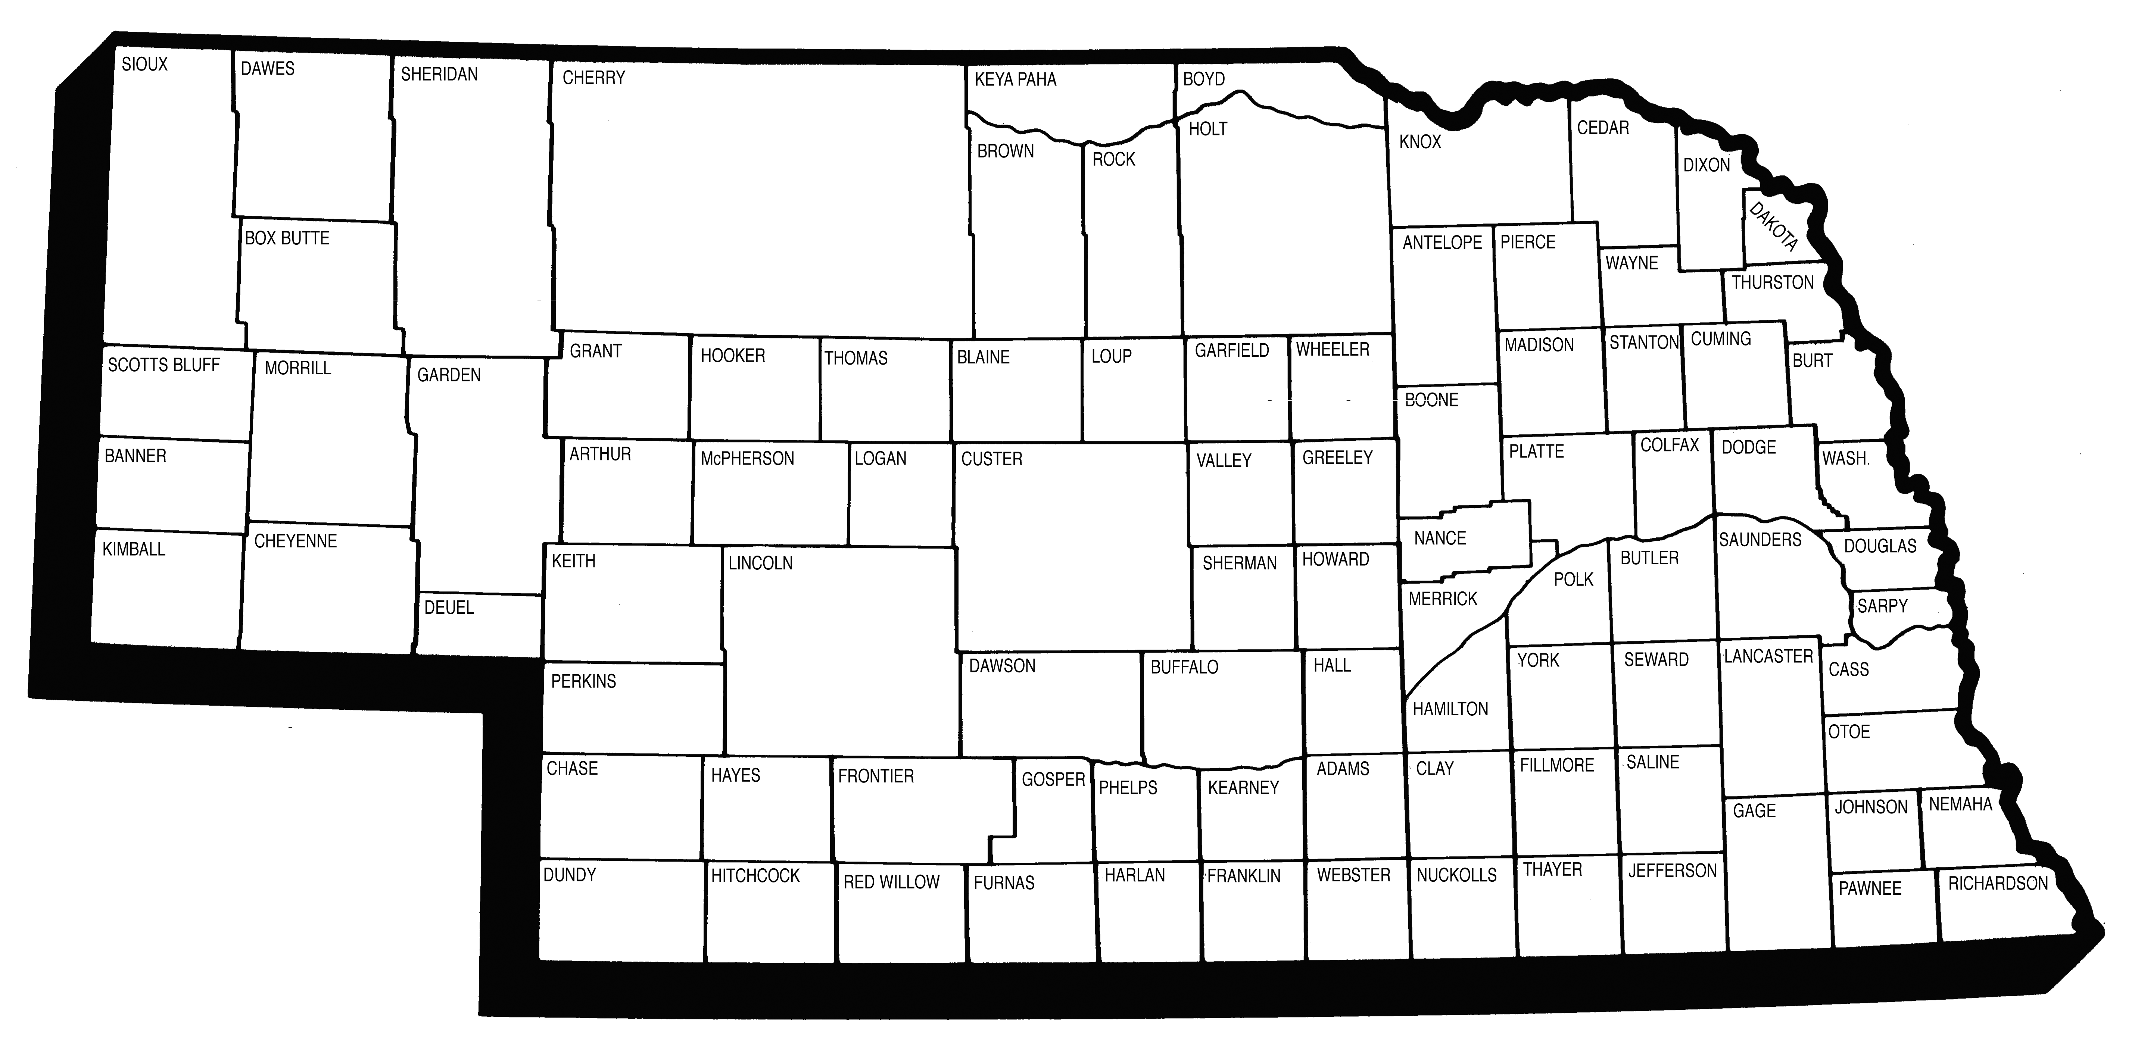

May 2005

Dave Heineman John L. Craig
Governor Director

Click on these titles for Index Pages:
Taxi Service | Rural Public Transportation
Intercity Bus Transportation | Urban Public Transportation
Nebraska Counties

Adams
Antelope
Arthur
Banner
Blaine
Boone
Box Butte
Boyd
Brown
Buffalo
Burt
Butler
Cass
Cedar
Chase
Cherry
Cheyenne
Clay
Colfax
Cuming
Custer
Dakota
Dawes
Dawson
Deuel
Dixon
Dodge
Douglas
Dundy
Fillmore
Franklin
Frontier
Furnas
Gage
Garden
Garfield
Gosper
Grant
Greeley
Hall
Hamilton
Harlan
Hayes
Hitchcock
Holt
Hooker
Howard
Jefferson
Johnson
Kearney
Keith
Keya Paha
Kimball
Knox
Lancaster
Lincoln
Logan
Loup
Madison
McPherson
Merrick
Morrill
Nance
Nemaha
Nuckolls
Otoe
Pawnee
Perkins
Phelps
Pierce
Platte
Polk
Red Willow
Richardson
Rock
Saline
Sarpy
Saunders
Scotts Bluff
Seward
Sheridan
Sherman
Sioux
Stanton
Thayer
Thomas
Thurston
Valley
Washington
Wayne
Webster
Wheeler
York

Taxi Service

Beatrice
Yellow Cab Co.
Columbus
City Taxi
Fremont
City Cab LLC
Hastings
Hastings Taxi & Transportation Services
Kearney
Kearney Cab Co.
Lincoln
Husker Cab Inc., DBA Capital Cab Co., DBA Yellow Cabs
Nebraska City
Tree City Cab Co.
Norfolk
Checker Cab
North Platte
E & M Cab Company
Omaha
Airport Transportation Co.
Checker Cab Co.
Cornhusker Cab Metro Express
Happy Cab Co.
Safeway Cabs, Inc.
Yellow Cab Co.
Plattsmouth
Plattsmouth Cab Co., Inc.
Scottsbluff
CABCO, Inc.
South Sioux City
AA Action Taxi & Limo
Siouxland Paramedic, Inc. Specialty Services
York
M. G. Taxi Service
Gage County

Taxi Service – Yellow Cab Co. (Beatrice)

Contact: Ron Hippen
Yellow Cab Co.
722 North 13th Street, Box 7
Beatrice, NE 68310

Telephone: (402) 223-3121

Description of System:
Taxi service operating in Beatrice and vicinity

Days and Hours of Operation:
7:00 a.m. – 6:00 p.m. – Monday – Friday
8:00 a.m. – 5:00 p.m. – Saturday
Closed Sunday and holidays

Rate Schedule:
$3.50 first mile
$1.50 for each additional mile
$1.40 per mile out of town

Number of Vehicles:
2 taxicabs
Platte County

Taxi Service – City Taxi (Columbus)

Contact: Richard Schamp
City Taxi
92 Cottonwood Drive
Columbus, NE 68601

Telephone: (402) 563-3334

Description of System:
Taxi service operating in Columbus and vicinity

Days and Hours of Operation:
6:00 a.m. to 10:00 p.m. each day except for Sunday and holidays

Rate Schedule:
$1.75 for the first 1/6 mile
25 cents for each additional 1/6 of a mile
$1.25 a mile for trips outside the city limits
10 cents for each 1-minute waiting time
$1.00 handling charge on small freight packages

Number of Vehicles:
3 taxicabs
Dodge County

Taxi Service – City Cab LLC (Fremont)

Contact: Dan Norman
City Cab LLC
PO Box 1395
Fremont, NE 68026-1395

Telephone: (402) 721-2121
E-mail: citycabllc@hotmail.com

Description of System:
Taxi service operating in Fremont and vicinity

Days and Hours of Operation:
7:00 a.m. – 7:00 p.m. – Monday through Friday
7:30 a.m. – 5:00 p.m. – Saturday

Rate Schedule:
$2.00 for the first 1/7 mile
25 cents for each additional 1/7-mile
No additional charge extra passengers
30 cents a minute waiting time
Deliveries are meter fare plus 50 cents
After hours by appointment

Number of Vehicles:
2 taxicabs
Adams County

Taxi Service – Hastings Taxi & Transportation Services (Hastings)

Contact: Chuck Gowin
Hastings Taxi & Transportation Services
P.O. Box 93
Hastings, NE 68902

Telephone: (402) 831-8294
Fax: (402) 462-2113
E-mail: hastingstaxi@inebraska.com

Description of System:
Taxi service
Manager: Gayla Clinard

Days and Hours of Operation:
6:30 a.m. to 11:00 p.m., 7 days a week
No service on holidays

Rate Schedule:
$2.00 for the 1st 1/6 of a mile
30 cents for each additional 1/6 of a mile
$1.00 for each additional passenger over the age of 12
35 cents for each minute waiting time
Trips of 40 miles or less, $1.25 per mile
Trips over 40 miles, but less than 80 miles, $1.10 per mile
Trips exceeding 80 miles, $1.00
Buffalo County

Taxi Service – Kearney Cab Co. (Kearney)

Contact: Dan or Susan Sindt
Kearney Cab Co.
1100 Avenue C #18
Kearney, NE 68847

Telephone: (308) 234-6725

Description of System:
Taxi service operating in Kearney and vicinity

Days and Hours of Operation:
24 hours a day, 7 days a week service

Rate Schedule:
Within city limits of Kearney:
$2.25 for the first 1/5 mile
25 cents for each additional 1/5-mile or fraction thereof
75 cents each additional passenger and baggage
25 cents per mile waiting time

Number of Vehicles:
5 taxicabs
1 minivan
Lancaster County

Taxi Service – Husker Cab Inc., DBA Capital Cab Co.,
DBA Yellow Cabs (Lincoln)

Contact: Donna Corey
Husker Cab Inc., DBA Capital Cab Co., DBA Yellow Cabs
320 West P
Lincoln, NE 68528

Telephone: (402) 477-6074 or (402) 477-4111

Description of System:
Taxi service operating in the City of Lincoln and to any points in the state.

Days and Hours of Operation:
24 hours a day, 7 days a week, including holidays

Rate Schedule:
$1.80 for the first 1/7 mile, 25 cents for each additional 1/7-mile
40 cents per minute waiting
No additional charge for extra passengers to and from same point
60 cents per unattended deliver, plus the meter

Number of Vehicles:
18 taxicabs

Otoe County

Taxi Service – Tree City Cab Co. (Nebraska City)

Contact: Ron Allgood or Darlene Allgood
Tree City Cab Co.
PO Box 544
1501 1st Corso
Nebraska City, NE 68410

Telephone: (402) 873-6058 or (402) 297-9333

Description of System:
Taxi service operating in Nebraska City and vicinity

Days and Hours of Operation:
5:00 a.m. – 7:00 p.m. – Monday through Friday
5:00 a.m. – 12:00 p.m. – Saturday
Sunday – no service
On call for emergencies during off-hours

Rate Schedule:
$3.50 base fare in Nebraska City
50 cents for each additional passenger or luggage
$3.50 for telegrams or packages
$3.50 plus $1.35 per mile outside of city limits
25 cents per minute waiting time

Number of Vehicles:
2 vans
Madison County

Taxi Service – Checker Cab (Norfolk)

Contact: Robert Nichols & Diann Nichols
Checker Cab
P.O. Box 1902
Norfolk, NE 68701

Telephone: (402) 371-5800

Description of System:
Taxi service operating in Norfolk and vicinity

Days and Hours of Operation:
6:00 a.m. – midnight
7 days a week, including holidays

Rate Schedule:
$1.75 for the first 1/7 mile, 20 cents for each additional 1/7-mile
50 cents for each additional passenger over 12 years of age
40 cents per minute waiting time
$1.50 for small packages in the city limits
$1.25 per mile per passenger outside the city limits (one way)
75 cents per mile per passenger outside the city limits for return trip
25 cents per mile for each additional passenger over 12 years of age outside the city limits

Number of Vehicles:
4 taxicabs
Lincoln County

Taxi Service – E & M Cab Company (North Platte)

Contact: Mary Saighman
E & M Cab Company
517 North Bailey Street
North Platte, NE 69101

Telephone: (308) 532-2345

Description of System:
Taxi service operating in North Platte and vicinity
Delivery service available

Days and Hours of Operation:
6:00 a.m. – 1:30 a.m., 7 days a week

Rate Schedule:
$2.60 for the first 1/8 mile within the city limits
20 cents for each additional 1/8-mile
10 cents for each additional passenger
30 cents per minute waiting time
$1.60 per mile outside the city limits

Number of Vehicles:
2 taxicabs
2 vans
Douglas County

Taxi Service – Airport Transportation Co. (Omaha)

Contact: Vincent LaLomia, President
Airport Transportation Co.
6502 Grover St.
Omaha, NE 68106

Telephone: (402) 339-6300 – General Office
(402) 339-8294 – Dispatch Office

Description of System: Airport Transportation Co. transports passengers by limousine between Omaha’s transportation terminals and between such terminals on the one hand, and, on the other hand, airline ticket offices and motels in an area comprising a portion of metropolitan Omaha, except any part of Iowa, bordered by the Missouri River on the east, I-680 on the north, 144th Street on the west, Highway 370 on the south, including service to and from Offutt Air Force Base except that service to and from Offutt Air Force Base shall be on a call-and-demand basis only, not a scheduled service.

1. Motel includes hotel.
2. Public transportation terminal means bus depots, railroad stations, and airports.
3. All passengers to be loaded or discharged at hotels, motels, bus depots, airline ticket
offices, railroad stations, or airport.
4. Passengers at airline ticket offices must be discharged at airport.
5. Service must be provided in limousine vehicles.
6. No service between bus depots and train stations, or between motels and such depots.

Days and Hours of Operation:
24 hours per day, 7 days per week, including holidays

Douglas County

Taxi Service – Checker Cab Co. (Omaha)

Contact: Vincent LaLomia, President
Checker Cab Co.
10770 “I” Street
Omaha, NE 68127

Telephone: (402) 339-3003 – General Office
(402) 342-8000 – Dispatch Office

Description of System: Checker Cab Co. transports passengers on demand or by advance reservation via taxicabs within the City of Omaha; and between points in Washington, Dodge, Saunders, Douglas, Sarpy and Cass Counties; and vicinity.

Days and Hours of Operation:
24 hours per day, 7 days per week, including holidays

Rate Schedule:
$1.80 for the first 1/6-mile or fraction thereof
25 cents for each additional 1/5-mile or fraction thereof after the first 1/6 mile
25 cents for each 75 seconds waiting time
$2.00 for refusal of ordered service upon arrival of taxicab at point of commencement of trip
No charge for additional passengers
$16.00 per hour for taxicab hired by the hour with a two-hour minimum charge; $4.00 for each ¼ hour or fraction thereof after the two-hour minimum

Number of Vehicles:
19 taxicabs

Douglas County

Taxi Service – Cornhusker Cab Metro Express (Omaha)

Contact: Joe Chase, Chief Operations Officer
Cornhusker Cab Metro Express
501 Olson Drive #213
Papillion, NE 68046

Telephone: (402) 734-5556

Description of System:
Taxi service operating in Omaha metro area

Days and Hours of Operation:
6:00 a.m. – 2:00 a.m., 7 days a week

Rate Schedule:
Initial Drop: $1.95 and $.30 for every 1/6 of a mile and $.35 per minute of waiting time
Initial Drop: $1.95 and $.20 for every 1/7 of a mile and $.35 per minute of waiting time
Initial Drop: $2.00 and $2.00 for every one (1) mile and $.35 per minute of waiting time

Number of Vehicles:
38 taxicabs

Douglas County

Taxi Service – Happy Cab Co. (Omaha)

Contact: Vincent LaLomia, President
Happy Cab Co.
10770 “I” Street
Omaha, NE 68127

Telephone: (402) 339-3003 – General Office
(402) 339-0110 – Dispatch Office

Description of System: Happy Cab Co. transports passengers on demand or by advance reservation via taxicabs within the City of Omaha; and between points in Washington, Dodge, Saunders, Douglas, Sarpy and Cass Counties; and vicinity.

Days and Hours of Operation:
24 hours per day, 7 days per week, including holidays

Rate Schedule:
$1.80 for the first 1/6-mile or fraction thereof
25 cents for each additional 1/5-mile or fraction thereof after the first 1/6 mile
25 cents for each 75 seconds waiting time
$2.00 for refusal of ordered service upon arrival of taxicab at point of commencement of trip
No charge for additional passengers
$16.00 per hour for taxicab hired by the hour with a two-hour minimum charge; $4.00 for each ¼ hour or fraction thereof after the two-hour minimum

Number of Vehicles:
56 taxicabs

Douglas County

Taxi Service – Safeway Cabs, Inc. (Omaha)

Contact: Dennis Miller or Scott Miller
Safeway Cabs, Inc.
802 South 14th Street
Omaha, NE 68108

Telephone: (402) 342-7474

Description of System: Taxi service operating in Omaha and vicinity

Days and Hours of Operation:
24 hours a day, 7 days a week

Rate Schedule:
$1.95 for the first 1/6 mile
30 cents for each 1/6-mile
No additional charge for additional passengers or luggage
$2.00 per mile if more than 20 miles from point of origin to destination
$20.00 per hour waiting time
$6.00 for refusal of ordered service upon arrival of taxicab at point of commencement of trip
$20.00 per hour for taxicab hired by the hour with a two-hour minimum charge; fractional time thereafter shall be completed on the basis of $5.00 for each ¼ hour or fraction thereof.

Number of Vehicles:
28 taxicabs

Douglas County

Taxi Service – Yellow Cab Co. (Omaha)

Contact: Vincent LaLomia, President
Yellow Cab Co.
6502 Grover St.
Omaha, NE 68106

Telephone: (402) 339-6300 – General Office
(402) 339-8294 – Dispatch Office

Description of System: Yellow Cab Co. transports passengers on demand or by advance reservation via taxicabs within the City of Omaha; and between points in Washington, Dodge, Saunders, Douglas, Sarpy and Cass Counties; and vicinity.

Days and Hours of Operation:
24 hours per day, 7 days per week, including holidays

Rate Schedule:
$1.95 for the first 1/6 mile or fraction thereof 30 cents for each additional 1/6-mile or fraction thereof after the first 1/6 mile
33 cents for each 60 seconds waiting time
$6.00 for refusal of ordered service upon arrival of taxicab at point of commencement of trip
No charge for additional passengers
$20.00 per hour for taxicab hired by the hour with a two-hour minimum charge; $5.00 for each ¼ hour or fraction thereof after the two-hour minimum

Number of Vehicles:
30 taxicabs

Flat rates for Happy, Checker and Yellow Cab:
The following rates are based on the most direct route between the Eppley Airfield main passenger terminal and hotels/motels.
Rates per Trip | Location
$14.05 | American Family Inn, 1110 Ft. Crook Road South
$26.65 | Ben Franklin Motel, I-80 and South 144th Street
$ 2.50 | Best Western Airport Inn, Eppley Airfield
$12.70 | Best Western Central-Omaha, 3650 South 72nd Street
$10.20 | Best Western Immanual Plaza Motel, 6901 North 72nd Street
$11.50 | Best Western New Tower Inn, 7764 Dodge Street
$16.75 | Best Western Omaha Inn, 4706 South 108th Street
$15.00 | Best Western Regency West, 909 South 107th Avenue
$13.00 | Best Western White House Inn, 305 Ft. Crook Road North
$16.75 | Budgetel Inn, 10760 “M” Street
$16.90 | Clarion Carlisle Hotel, 10909 “M” Street
$ 7.90 | Colonial Hotel, 3804 Farnam Street
$16.75 | Comfort Inn, 10919 “J” Street
$13.00 | Days Inn, 7101 Grover Street
$12.40 | Embassy Suites Hotel, 7270 Cedar Street
$ 6.60 | Excel Inn, 2211 Douglas Street
$17.05 | Fireside Suites, 11025 “M” Street
$16.75 | Hampton Inn, 10728 “L” Street
$13.60 | Hampton Inn, 9720 West Dodge Road
$28.05 | Hi-Way House Motor Inn, I-80 and Highway 370
$13.00 | Holiday Inn Central, 3321 South 72nd Street
$ 7.35 | Holiday Inn Express, 3001 Chicago Street
$15.40 | Holiday Inn Old Mill, 655 North 108th Avenue
$12.40 | Homewood Suites, 7010 Hascall Street
$14.05 | LaQuinta Motor Inn, 3330 North 104th Avenue
$12.25 | Leisure Inn Motel, 4815 “L” Street
$20.05 | Liberty Lodge, 1409 Gold Coast Road
$13.95 | Marriott Hotel, 10220 Regency Circle
$16.75 | Motel 6, 10708 “M” Street
$14.65 | Motel 89, 4305 South 89th Street
$12.10 | Oak Creek Inn, 2808 South 72nd Street
$14.80 | Offutt Air Force Base, North Gate, U.S. Highway 73-75
$16.65 | Offutt Air Force Case, South Gate, U.S. Highway 73-75
$16.05 | Offutt Motor Court, U.S. Highway 73-75
$25.90 | Park Inn International, I-80 and Highway 50
$15.40 | Quality Inn Crown Court, Highway 370 and Hillcrest Drive
$ 6.15 | RadissonRedick Tower Hotel, 1504 Harney Street
$ 3.85 | Ramada Inn Airport, Abbott Drive and Locust Street
$12.90 | Ramada Inn Central, 7007 Grover Street
$ 6.10 | Red Lion Inn, 1616 Dodge Street
$11.70 | Redweed Motel, U.S. Highway 73-75
$10.75 | Residence Inn Central, 6990 Dodge Street
$13.45 | Sandman Motel, 105 Ft. Crook Road South
$13.60 | Satellite Motel, 6006 “L” Street
$16.75 | Savannah Suites, 4809 South 107th Avenue
$17.95 | Sheraton Inn Southwest, 4888 South 118th Street
$14.35 | Slumber Crest Motel, 1201 Ft. Crook Road South
$12.25 | Super 8 Ak-Sar-Ben Motel, 7111 Spring Street
$16.90 | Super 8 Omaha Motel, 10829 “M” Street
$17.80 | Townhouse Inn, 13929 Gold Circle
$ 8.05 | Travel Inn, 3902 Dodge Street
$11.80 | Wayside Inn Motor Hotel, 7833 Dodge Street
The above flat-rated fares do not include gratuities. The offering of gratuities is voluntary and a passenger responsibility.
The above flat-rated fare does not include provisions for stopping enroute and no stops will be authorized.
Any deviation from the most direct route on the above flat-rated fares, including stops enroute, is at the passenger direction and the meter will be employed.
Where the hotel/motel agrees to pay the transportation cost and the passenger authorizes a route deviation, the passenger is responsible for the difference between the meter fare and the flat-rated fare.
Cass County

Taxi Service – Plattsmouth Cab Co., Inc. (Plattsmouth)

Contact: Ron Bertsch
Plattsmouth Cab Co., Inc.
106 South 5th Street
Plattsmouth, NE 68048

Telephone: (402) 296-4000

Description of System:
Taxi service operating in Plattsmouth and vicinity

Days and Hours of Operation:
24 hours per day, 7 days a week

Rate Schedule:
$5.00 in Plattsmouth
$1.75 per mile out of town
No charge for additional passengers

Number of Vehicles:
3 taxicabs

Scotts Bluff County

Taxi Service – CABCO, Inc. (Scottsbluff)

Contact: Lori Cape
CABCO, Inc.
2425 Avenue “I”
Box 727
Scottsbluff, NE 69361

Telephone: (308) 632-2224

Description of System:
Taxi service operating in Scottsbluff and surrounding areas

Days and Hours of Operation:
Monday through Thursday – 6:00 a.m. – 10:00 p.m.
Friday and Saturday – 6:00 a.m. – 1:00 a.m.

Rate Schedule:
Meter rate of $2.25 plus 25 cents for every 1/8-mile
$1.25 per mile outside Scottsbluff and Gering
$1.00 for each extra passenger
25 cents per minute waiting time
$5.00 courier and messenger service within the Panhandle
Meters run on mileage and time

Number of Vehicles:
2 taxicabs
Dakota County

Taxi Service – AA Action Taxi & Limo (South Sioux City)

Contact: Don Herdzig
AA Action Taxi & Limo
625 Water St.
Sioux City, IA

Telephone: (712) 252-4777

Description of System:
Taxi service operating in Sioux City and vicinity

Days and Hours of Operation:
24 hours a day, 7 days a week

Rate Schedule:
$1.70 for the first 1/12 mile, 10 cents for each additional 1/12-mile
$20.00 waiting time per hour

Minimum Charges
$3.00 from Missouri River (1st Ave. Bridge) to 21st St. in South Sioux City
$5.00 from 21st St. to Hwy. 20
$8.00 from Hwy. 20 to Dakota City

Number of Vehicles:
12 taxicabs

Dakota County

Taxi Service – Siouxland Paramedic, Inc. Specialty Services
(South Sioux City)

Contact: Don Zeman
Siouxland Paramedic, Inc. Specialty Services
Wheelchair Transportation Service
1903 7th Street
Sioux City, IA 51101

Telephone: (712) 252-1632

Description of System:
Taxi service operating in Sioux City and vicinity.
Providing service for wheelchair and other special transportation needs.

Days and Hours of Operation:
24 hours a day, 7 days a week, including holidays

Rate Schedule:
Contact operator for rates

Number of Vehicles:
14 vans, 7 with ramp for wheelchair and stretcher
7 vans with lifts and equipped to mount stretchers
3 Winstar
One 5-passenger non-lift or ramp van
York County

Taxi Service – M. G. Taxi Service (York)

Contact: Irene Williams (402) 486-4060
M. G. Taxi Service
219 Blackburn Ave.
York, NE 68467

Telephone: (402) 362-1313

Description of System:
Taxi service operating in York and vicinity

Days and Hours of Operation:
7 days a week

Rate Schedule:

Within York city limits including I-80 Interchange | $ 5.00
Senior Citizen Rate | $ 4.00
Any town within a 10-mile radius of York city limits | $10.00 (one way)  $18.00 (round trip)*
Senior Citizen Rate | $ 8.00 (one way)  $16.00 (round trip)*
Any town within a 15-mile radius of York city limits | $15.00 (one way)  $25.00 (round trip)*
Senior Citizen Rate | $12.00 (one way)  $20.00 (round trip)*
Any town within a 20-mile radius of York city limits | $20.00 (one way)  $35.00 (round trip)*
Senior Citizen Rate | $16.00 (one way)  $28.00 (round trip)*
Service to Lancaster County | $35.00
Senior Citizen Rate | $30.00
Service to Sarpy or Douglas County | $60.00
Senior Citizen Rate | $54.00
Waiting Fee after 15 minutes | $ .50
Any other service not covered above is at a per mile rate | $ 3.00 (first mile)
Additional miles | $ 1.00 (per mile)
* This includes a 15-minute wait. Any additional wait time will be charged in accordance.

Number of Vehicles:
1 taxicab

Intercity Bus Transportation

Black Hills Stage Lines, Inc.
Blue Rivers Transportation System
Intercity Eastern Route
Blue Rivers Transportation System
Intercity Western Route
Dashabout Shuttle
Denver Coach, Inc.
Eppley Express
Greyhound Lines, Inc.
K & S Express
Intercity Bus Transportation – Black Hills Stage Lines, Inc.

Contact: Black Hills Stage Lines, Inc.
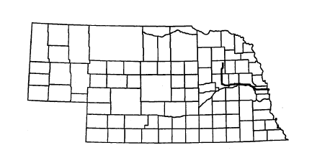
720 East Norfolk Avenue
Norfolk, NE 68701

Telephone: (402) 371-3850
In-State Toll Free 1-800-672-8302

Description of System: Norfolk to Omaha via Columbus and Fremont

Days and Hours of Operation:
Norfolk to Omaha, Monday through Friday

City | Depart | Arrive
Norfolk | 8:30 a.m. | 4:00 p.m.
Columbus | 9:30 a.m. | 2:50 p.m.
Schuyler | 9:55 a.m. | 2:25 p.m.
Fremont | 10:35 a.m. | 1:55 p.m.
(Need reservation for Fremont)

Arrive in Omaha at 11:30 a.m. and depart 1:15 p.m.

Rate Schedule:
Contact Black Hills Stage Lines, Inc.

Intercity Bus Transportation – Blue Rivers Transportation System
Intercity Eastern Route
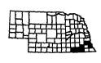
Communities Served:

Auburn | Douglas | Nebraska City | Peru
Avoca | Dunbar | Nehawka | Syracuse
Brock | Johnson | Nemaha | Talmage
Brownville | Julian | Otoe | Unadilla
Burr | Lorton | Palmyra | Union
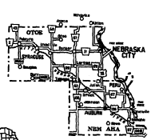
Contact: Larry Ossowski, Director
Blue Rivers Area Agency on Aging
Room 24, Courthouse
612 Grant St.
Beatrice, NE 68310

Local Contact: Call the office nearest to you:

Telephone: Auburn (402) 274-5365
Nebraska City (402) 873-3005
Syracuse (402) 269-5129

Nebraska Association of Transportation Providers member

Description of System: The Blue Rivers Inter-City (East) Transportation System operates in Nemaha and Otoe counties on a demand-response, portal-to-portal, 24-hour advance reservation basis. Vehicle is stationed in Auburn. Routes are scheduled to Lincoln and Omaha. Stops are made in Nebraska City and Syracuse.

Days and Hours of Operation:
Tuesdays – Wednesdays – Fridays: Provides transportation to Lincoln two days per week and Omaha one day per week.
Tuesday: Highway 75 from Auburn to Nebraska City then to Highway 34 and then to Lincoln. Van leaves Auburn at 8:00 – 8:15 a.m. and arrives in Lincoln at 9:45 – 10:00 a.m. Van leaves Lincoln at 3:00 – 3:15 p.m. on the return trip.
First, second and third Wednesdays: Highway 75 from Auburn to Nebraska City, then to Omaha.
Fourth Wednesday: Highway 75 from Auburn to Nebraska City, then to Syracuse, then to Omaha. Van leaves Auburn at 8:00 – 8:15 a.m. Arrives in Omaha at 10:15 – 10:30 a.m. Van leaves Omaha at 2:45 – 3:00 p.m. for return trip.
First and Third Fridays: Highway 136 from Auburn to Highway 105/67 then to Highway 2, then to Lincoln. Van leaves Auburn at 8:00 – 8:15 a.m. and arrives in Lincoln at 9:45 – 10:00 a.m. Van leaves Lincoln at 3:00 – 3:15 p.m. for return trip.
Second and Fourth Fridays: Highway 75 from Auburn to Nebraska City, then to Syracuse, then to Lincoln. Van leaves Auburn at 8:00 – 8:15 a.m. and arrives in Lincoln at 9:45 – 10:00 a.m. Van leaves Lincoln at 3:00 – 3:15 p.m. on the return trip.
Provides service to communities along designated route highways. Some restrictions may apply. Call the office nearest you for more information.

Rate Schedule:
$1.25 per one-way trip within a community
$2.50 per one-way trip between communities
$6.00 per one-way trip to Lincoln, Omaha

Number of Vehicles:
One 11-passenger van with lift
Intercity Bus Transportation – Blue Rivers Transportation System
Intercity Western Route
Communities Served:

Adams | Clatonia | Gilead | Odell
Alexandria | Cortland | Gladstone | Pickrell
Barneston | Davenport | Harbine | Plymouth
Beatrice | Daykin | Hebron | Powell
Belvidere | Deshler | Holmesville | Rockford
Blue Springs | Ellis | Hubbell | Reynolds
Byron | Endicott | Jansen | Steele City
Carleton | Fairbury | Lanham | Thompson
Chester | Filley | Liberty | Virginia
 |  |  | Wymore

Contact: Larry Ossowski, Director
Blue Rivers Area Agency on Aging
Room 24, Courthouse
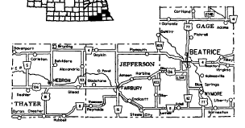

612 Grant St.
Beatrice, NE 68310

Local Contact: Call the office nearest to you:

Telephone: Beatrice (402) 223-1357
Wymore (402) 645-3525
Fairbury (402) 729-6475
Hebron (402) 768-6052

Nebraska Association of Transportation Providers member

Description of System: The Blue Rivers Inter-City (West) Transportation System operates in Gage, Jefferson and Thayer counties on a demand-response, portal-to-portal, 24-hour advance reservation basis. Vehicle is stationed in Hebron. Routes are scheduled to Lincoln weekly, Mondays, Wednesdays, and Thursdays. Stops are made in Fairbury and Beatrice.

Days and Hours of Operation:
Mondays – Wednesdays - Thursdays
Provides transportation to Lincoln three days per week.
Highway 136 from Hebron to Fairbury, then to Beatrice, and then to Lincoln. Van leaves Hebron at 7:15 – 7:30 a.m. Arrives in Fairbury at 7:45 – 8:00 a.m. in Beatrice at 8:30 – 8:45 a.m. and in Lincoln at 9:45 – 10:00 a.m. Van leaves Lincoln at 3:00 – 3:15 p.m. for return trip.
Provides service to communities along designated route. Some restrictions may apply. Call the office nearest you for more information.

Rates Schedule:
$1.25 per one-way trip within a community
$2.50 per one-way trip between communities
$6.00 per one-way trip to Lincoln, Omaha

Number of Vehicles:
One 11-passenger van with lift
Intercity Bus Transportation – Dashabout Shuttle
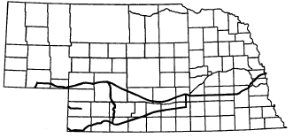
Contact: Lea Holtorf
Dashabout shuttle
Buffalo Springs Ranch
Akron, CO 80720

Telephone: 1-800-720-DASH
(970) 345-6613
Emergency (970) 345-6395

Nebraska Association of Transportation Providers member

Description of System: Scheduled van service operating over three different routes in Nebraska. The first runs from North Platte, Ogallala, Big Springs, Chappell, and Sidney with flag stops. The second route runs from McCook, Trenton, Benkelman, and Haigler with flag stops. The third runs from Imperial to Denver, Colorado. These three routes meet at the Atwood, Colorado interchange along I-76 and then continue to Ft. Collins, Greeley, Boulder, and Denver, Colorado. Passenger stops can be made at Peetz, Sterling, Brush, Ft. Morgan, Wray, Yuma, and Akron, Colorado. Reservations are required 24 hours in advance.

Days and Hours of Operation:
Office hours, 8:00 a.m. – 5:00 p.m., Monday through Friday. Service is provided daily.

(Monday through Sunday)
North Platte – Denver
Depart - North Platte | 5:45 a.m. CST
- Ogallala | 5:45 a.m.
- Big Springs | 6:00 a.m.
- Chappell | 6:30 a.m.
- Sidney | 7:00 a.m.
Arrive - Denver | 10:00 a.m.
- Boulder | 11:00 a.m. (Friday)
- Greeley | 11:00 a.m. (Monday – Sunday)
Saturday & Sunday – Arrive and depart two hours later.

McCook – Denver
Depart - McCook | 5:45 a.m. CST
- Benkelman | 5:45 a.m.
- Haigler | 6:00 a.m.
Arrive - Denver | 10:00 a.m.
Saturday & Sunday – Arrive and depart two hours later.

(Wednesday)
Imperial – Denver
Depart - Imperial | 6:00 a.m.
Arrive - Denver International Airport | 10:00 a.m.
- Downtown Denver | 10:30 a.m.
- Ft. Collins, Colorado | 12:00 Noon

(Friday, Saturday, Sunday and Monday)
Denver – North Platte
Depart - Downtown Denver | 5:30 p.m.
Depart - Denver International Airport | 6:00 p.m.
Arrive - Sidney | 8:45 p.m. approx.
- Chappell | 9:15 p.m. approx.
- Big Springs | 9:40 p.m. approx.
- Ogallala | 10:00 p.m. approx.
- North Platte | 12:00 Midnight CST

Denver – McCook
Depart - Downtown Denver | 5:30 p.m.
Depart - Denver International Airport | 6:00 p.m.
Arrive - Haigler | 10:00 p.m.
- Benkelman | 10:30 p.m.
- McCook | 12:00 Midnight CST

(Wednesday)
Denver – Imperial
Depart - Downtown Denver | 2:30 p.m.
Depart - Denver International Airport | 3:00 p.m.
Arrive - Imperial | 6:00 p.m.

(Tuesday, Wednesday and Thursday)
Denver – North Platte
Depart - Downtown Denver | 2:30 p.m.
Depart - Denver International Airport | 3:00 p.m.
Arrive - Sidney | 6:00 p.m. approx.
- Chappell | 6:30 p.m. approx.
- Big Springs | 6:55 p.m. approx.
- Ogallala | 7:15 p.m. approx.
- North Platte | 9:15 p.m. CST

Denver – McCook
Depart - Downtown | 2:30 p.m.
Depart - Denver International Airport | 3:00 p.m.
Arrive - Haigler | 6:30 p.m. approx.
- Benkelman | 7:00 p.m. approx.
- McCook | 9:00 p.m. CST

(Monday & Friday)
McCook – Grand Island
Depart |  | Arrive
5:45 a.m. | McCook | 9:20 p.m.
6:00 a.m. | Indianola | 9:10 p.m.
6:10 a.m. | Bartley | 9:00 p.m.
6:20 a.m. | Cambridge | 8:50 p.m.
6:30 a.m. | Holbrook | 8:40 p.m.
6:40 a.m. | Arapahoe | 8:30 p.m.
6:50 a.m. | Edison | 7:20 p.m.
7:00 a.m. | Oxford | 8:10 p.m.
7:15 a.m. | Atlanta | 7:55 p.m.
7:25 a.m. | Holdrege | 7:45 p.m.
7:35 a.m. | Funk | 7:35 p.m.
7:15 a.m. | Kearney to Axtell | 6:55 p.m.
7:45 a.m. | Axtell | 7:25 p.m.
7:55 a.m. | Minden | 7:15 p.m.
8:10 a.m. | Heartwell | 7:00 p.m.
8:35 a.m. | Hastings | 6:35 p.m.
8:55 a.m. | Doniphan | 6:15 p.m.
9:00 a.m. | I-80 Interstate | 6:10 p.m.
9:10 a.m. | Grand Island | 6:00 p.m.

(Tuesday, Wednesday & Thursday)
McCook – Grand Island
Depart |  | Arrive
8:15 a.m. | McCook | 9:20 p.m.
8:30 a.m. | Indianola | 9:10 p.m.
8:40 a.m. | Bartley | 9:00 p.m.
8:50 a.m. | Cambridge | 8:50 p.m.
9:00 a.m. | Holbrook | 8:40 p.m.
9:10 a.m. | Arapahoe | 8:30 p.m.
9:20 a.m. | Edison | 7:20 p.m.
9:30 a.m. | Oxford | 8:10 p.m.
9:45 a.m. | Atlanta | 7:55 p.m.
9:55 a.m. | Holdrege | 7:45 p.m.
10:05 a.m. | Funk | 7:35 p.m.
9:45 a.m. | Kearney to Axtell | 6:55 p.m.
10:15 a.m. | Axtell | 7:25 p.m.
10:25 a.m. | Minden | 7:15 p.m.
10:40 a.m. | Heartwell | 7:00 p.m.
11:05 a.m. | Hastings | 6:35 p.m.
11:25 a.m. | Doniphan | 6:15 p.m.
11:30 a.m. | I-80 Interstate | 6:10 p.m.
11:40 a.m. | Grand Island | 6:00 p.m.

(Monday & Friday)
North Platte – Omaha
Depart |  | Arrive
5:45 a.m. | North Platte | 9:00 p.m.
9:25 a.m. | Grand Island | 6:00 p.m.
9:35 a.m. | Grand Island I-80 Interchange | 6:10 p.m.
11:00 a.m. | Lincoln | 4:15 p.m.
12:15 p.m. | Downtown Omaha | 3:05 p.m.
12:25 p.m. | Eppley Airport | 2:55 p.m.
 | With stops in Lexington and Kearney

(Tuesday, Wednesday & Thursday)
North Platte – Omaha
Depart |  | Arrive
8:15 a.m. | North Platte | 9:00 p.m.
11:55 a.m. | Grand Island | 6:00 p.m.
12:05 a.m. | Grand Island I-80 Interchange | 6:10 p.m.
1:30 a.m. | Lincoln | 4:15 p.m.
2:40 p.m. | Downtown Omaha | 3:05 p.m.
2:50 p.m. | Eppley Airport | 2:55 p.m.
 | With stops in Lexington and Kearney

(Monday & Friday)
McCook – North Platte
Depart – McCook | 5:45 a.m.
Arrive – North Platte | 7:00 a.m.

(Sunday, Tuesday, Wednesday, Thursday & Saturday)
McCook – North Platte
Depart – McCook | 8:15 a.m.
Arrive – North Platte | 9:30 a.m.
Return trips each day from North Platte at 9:30 p.m.

Rate Schedule: Contact Dashabout Shuttle
For more information concerning other rates along route, contact
Dashabout Shuttle.

Intercity Bus Transportation – Denver Coach, Inc.

Contact: Coyd Walker
Denver Coach, Inc.
4 Cedar Lane
Scottsbluff, NE 69361

Telephone: (308) 632-8400 1-800-658-3125

Description of System: Daily service connection Chadron, Hemingford, Alliance, Scottsbluff, Gering, Kimball, Mitchell, and Morrill, Nebraska with Denver, Colorado and intermediate points. All service by reservation only.
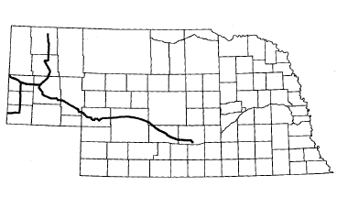

Two days a week service to Ogallala, North Platte and Kearney connecting with Eppley Express at Kearney and continuing service to Grand Island, Lincoln and Omaha.

Days and Hours of Operation:
Seven days a week, one trip each direction, to and from Denver, Tuesday/Friday to and from eastern Nebraska.

Rate Schedule:
$49.00 one-way between Denver, Colorado and Chadron, Nebraska
$45.00 one-way between Denver, Colorado and Hemingford, Nebraska
$41.00 one-way between Denver, Colorado and Alliance, Nebraska
$34.00 one-way between Denver, Colorado and Scottsbluff or Gering, Nebraska
$34.00 one-way between Denver, Colorado; Torrington, Wyoming and Mitchell and Morrill, Nebraska
$32.00 one-way between Denver, Colorado and Kimball, Nebraska
One-way between Scottsbluff, Gering or Alliance and:
Ogallala $29.00
North Platte $32.00
Kearney $37.00
Grand Island $51.00
Lincoln $66.00
Omaha $72.00

Add $8.00/one-way trip for service to and from Chadron and all points.

Intercity Bus Transportation – Eppley Express
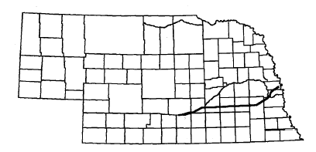
Contact: Eppley Express
P.O. Box 1924
Kearney, NE 68848

Telephone: (308) 234-6066 1-800-888-9793

Description of System: Van service operating between Kearney and Omaha, Nebraska

Pickup Points:
Kearney | Country Inn Suites (I-80 & Hwy. 10)
Grand Island & Hastings | Bosselman’s Travel Center (I-80 & Hwy. 281)
York | Holiday Inn (I-80 & Hwy. 81)
Lincoln | Ramada Inn Airport Inn & Airport
Omaha | Eppley Airfield (Door #3)
Omaha | Holiday Inn Central (72nd St. Exit)

Days and Hours of Operation:
Operating seven days a week except for holiday cancellations. Certain runs will not operate during holiday periods. Contact Eppley Express for details.

For arrival and departure times, contact Eppley Express for schedule changes in the spring and fall.

Rate Schedule:
Lincoln - Omaha $29.00
Grand Island & Hastings - Omaha $45.00
- Lincoln $38.00
- York $19.00
- Kearney $19.00
Kearney - Omaha $49.00
- Lincoln $41.00
- York $30.00
York - Omaha $39.00
- Lincoln $27.00

Children under 2 (held by an adult) - Free
Children age 2-11 (with adult) - 50% of fare

Intercity Bus Transportation – Greyhound Lines, Inc.

Contact: Greyhound Lines, Inc. Greyhound Lines, Inc.
Headquarters 1601 Jackson
P.O. Box 66036 Omaha, NE 68102
Dallas, TX 75266-0362 (402) 341-1906
(214) 777-8218

Telephone: Greyhound Nebraska Agencies
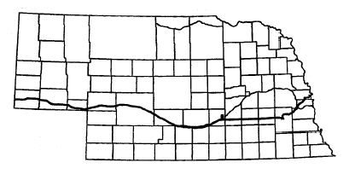
Chappell (308) 874-2912
Cozad (308) 784-4516
Gothenburg (308) 537-8706
Grand Island (308) 382-1810
Kearney (308) 237-2052
Kimball (308) 235-4514
Lexington (308) 324-4563
Lincoln (402) 474-1071
Lodgepole (308) 483-5515
North Platte (308) 532-2324
Ogallala (308) 284-2669
Omaha (402) 341-1906
Overton (308) 987-2381
Potter (308) 879-4454
Sidney (308) 254-5863
York Jct. (402) 362-3262

Description of System: Scheduled bus service between Omaha and Kimball, Nebraska along I-80.

Days and Hours of Operation:
7 days a week
Omaha – Kimball
Omaha | Kimball
Depart 1:45 a.m. | Arrive 9:55 a.m.
12:20 p.m. | 9:05 p.m.
Arrive 6:40 p.m. | Depart 6:05 a.m.

Omaha – Denver
Depart | Arrive
4:45 a.m. | 5:00 p.m.
9:00 a.m. | 8:30 p.m.
10:15 p.m. | 7:15 a.m.

For more details, contact Greyhound

Rate Schedule: Contact the Greyhound information center at 1-800-231-2222.
Intercity Bus Transportation – K & S Express

Contact: Ken and Sherry Thurlow
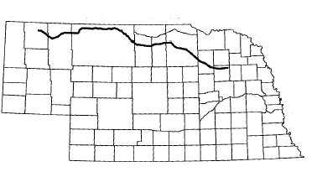
K & S Express
P.O. Box 184
Atkinson, NE 68713

Telephone: 1-800-425-2016
Fax: (402) 925-2016

Description of System: Scheduled bus service between Norfolk and Chadron along Highway 275 and Highway 20

Days and Hours of Operation: The Norfolk to Chadron schedule runs west on Tuesday and east on Wednesday. The Chadron to Norfolk schedule runs Wednesday morning by appointment. No holidays.

Tuesday |  | Wednesday
Departure Time | Destination | Departure Time | Destination
4:15 p.m. | Norfolk | 11:30 p.m. MT | Chadron
4:40 p.m. | Neligh | 12:15 a.m. | Rushville
5:30 p.m. | O’Neill | 12:30 a.m. | Gordon
6:00 p.m. | Atkinson | 3:30 a.m. CT | Valentine
6:30 p.m. | Bassett | 4:45 a.m. | Ainsworth
6:45 p.m. | Ainsworth | 5:00 a.m. | Bassett
7:45 p.m. | Valentine | 5:30 a.m. | Atkinson
9:30 p.m. MT | Gordon | 6:00 a.m. | O’Neill
9:45 p.m. | Rushville | 6:45 a.m. | Neligh
Arrive Chadron @10:15 p.m. |  | Arrive Norfolk @ 7:30 a.m.
NOTE: Norfolk to Valentine is Central Time and Gordon to Chadron is Mountain Time |  | NOTE: Chadron to Gordon is Mountain Time and Norfolk to Valentine is Central Time

Rate Schedule: The rate is 21 cents per mile from pickup point to destination point. A ten percent discount is given to senior citizens.

Urban Public Transportation

City of Bellevue Specialized Transportation Service
MAT
Papillion Transportation System
Ralston/LaVista Special Services Unit
Star Tran
Urban Public Transportation – City of Bellevue Specialized
Transportation Service
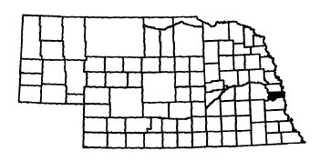
Contact: Ms. Karen Jackson
Human Service Director
1912 Hancock Street
Bellevue, NE 68005

Telephone: (402) 293-3138
Fax: (402) 293-3140

Nebraska Association of Transportation Providers member

Description of System: The City of Bellevue Specialized Transportation Service offers transportation to elderly and disabled persons of any age who reside within the Bellevue city limits. The mini buses operate Monday through Friday on a dial-a-ride basis into Omaha, Papillion, and Bellevue, and to the Senior Center, and Nutrition Site. Reservations are requested 48 hours in advance of service although exceptions are made for emergencies.
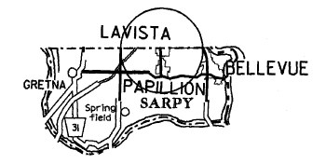

Days and Hours of Operation:
Monday through Friday: 8:00 a.m. – 4:00 p.m.

Rate Schedule:
Within the Bellevue city limits:
$1.00 one-way trip
$2.00 round trip

Outside the Bellevue city limits:
$2.00 one-way
$4.00 round trip

To and from the Senior Center:
$1.00 one-way
$2.00 round trip
Escorts ride free

Number of Vehicles:
3 full-time, lift-equipped passenger vans
1 part-time, lift-equipped passenger van
1 back-up, lift-equipped passenger van
Urban Public Transportation – Metro Area Transit (MAT)
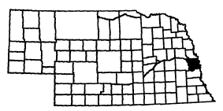
Contact: Curt Simon, Executive Director
2222 Cuming
Omaha, NE 68102

Telephone: (402) 341-7560
Fax: (402) 342-0949
E-mail: matbus@omamat.org
TDD: (402) 341-0807

Nebraska Association of Transportation Providers member
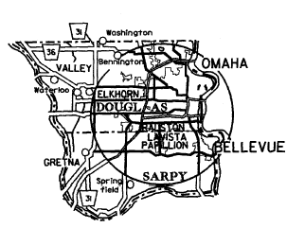

Description of System: Metro Area Transit provides fixed route and express service within the city limits of Omaha. The system is designed as a radial network using strategically located transit centers at local points along the heaviest corridors in the city to provide timed-transfer connections between all routes using the centers. Contract service is also provided by MAT to Bellevue, and the Tri-communities (Ralston, LaVista, Papillion) in Nebraska and Council Bluffs, Iowa. Demand-responsive paratransit service is provided for the disabled by our MOBY van service to all ADA certified applicants within the City of Omaha.

Days and Hours of Operation:
MAT: Monday through Friday:
4:00 a.m. – 11:00 p.m.
Saturday: 6:00 a.m. – 10:00 p.m.
Sunday: 7:00 a.m. – 7:00 p.m.
No holiday service
MOBY: Monday through Friday: 4:30 a.m. – 11:00 p.m.
Saturday: 7:00 a.m. – 9:30 p.m.
Sunday: 7:00 a.m. – 7:30 p.m.
No holiday service

Rate Schedule: | Nebraska | Iowa
Adult Regular | $1.25 | $1.25
Adult Express | 1.50 | -------
Student with MAT photo ID  (ages 12 through senior high) (Student fare in  effect before 6:00 p.m. on school days only) | 1.00 | 1.00
Child (age 5 through 11) | .50 | .50
Child (under 5 with adult) | Free | Free
Senior citizen/disabled (with MAT ID) | .60 | .60
Tri-Communities Express (93) | 1.50 | -------
Transfers (purchase when paying fare) | .05 | Free
Ten Ride Ticket Book | Per Book
Regular | $12.50
Regular with transfer | $13.00
Express | 15.00
Student | 10.00
Disabled/senior citizen & Medicare | 6.00
MOBY | 20.00

MOBY: $2.00 per one-way trip

Number of Vehicles:
MAT: 58 35’ transit coaches (100% lift-equipped)
73 40’ transit coaches (100% lift-equipped)
MOBY: 14 (lift-equipped)
Urban Public Transportation – Papillion Transportation System

Contact: Lori Hansen, Director
Papillion Parks & Recreation Department
122 East 3rd Street
Papillion, NE 68046

Telephone: (402) 597-2026
Bus: (402) 680-3970
Fax: (402) 597-2080

Description of System: This is a demand-responsive service providing service to the residents of Papillion. Three days a week, trips are made to Omaha. The other two days, service is provided in the Papillion area with trips to LaVista.

Days and Hours of Operation:
Monday through Friday: 7:30 a.m. – 4:00 p.m.

Rate Schedule:
Trips within Papillion:
50 cents per one-way trip/stop

Trips outside Papillion:
$1.00 per one-way trip/stop

Number of Vehicles:
1 bus, lift-equipped
Urban Public Transportation – Ralston/LaVista Special Services Unit
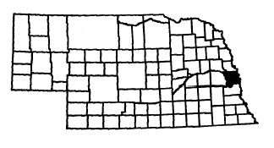
Contact: Dolores Costanzo
5500 South 77th Street
Ralston, NE 68127

Telephone: (402) 331-6677
Fax: (402) 331-4553

Nebraska Association of Transportation Providers member
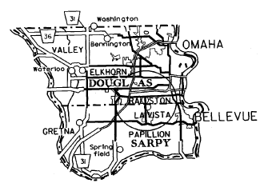
Description of System: The Ralston/LaVista Special Services Unit offers transportation to elderly and disabled persons in the corporate limits of the cities of Ralston and LaVista.

Days and Hours of Operation:
Monday through Friday: 7:00 a.m. – 3:30 p.m.

Rate Schedule:
Within the Ralston and LaVista city limits:
$1.00 per one-way trip
$2.00 round trip

Outside the Ralston and LaVista city limits:
$2.00 per one-way
$4.00 round trip

Number of Vehicles:
1 van, lift-equipped

Urban Public Transportation – Star Tran
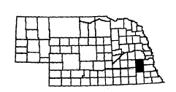

Contact: Larry Worth
Transit Manager
Public Works Department/Star Tran Division
710 “J” Street
Lincoln, NE 68508-2938
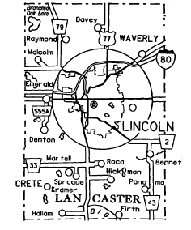

Telephone: (402) 441-7185
Fax: (402) 441-7055

Description of System: Star Tran provides public transit service to 20 regular fixed routes, and one downtown route. Star Tran also operates a demand-response paratransit service for eligible elderly and disabled patrons. The primary service structure is radically oriented, with the exception of the north-south cross-town route, focusing on the central business district of Lincoln. Annual ridership is approximately 1.8 million passengers.

Days and Hours of Operation: Star Tran operates on weekdays and Saturdays, generally between 5:15 a.m. and 7:10 p.m. Star Tran operates no evening or Sunday regular fixed route service. Weekday service generally operates on 30-minute headways during the peak period and 60-minute headways during the off-peak or base period. The paratranist service operates door-to-door, six days per week, 5:45 a.m. to 10:30 p.m. on weekdays and 6:00 a.m. to 6:00 p.m. on Saturdays.

Rate Schedule: Star Tran cash fare is $1.00, children 4 years and under, ride free; 50 cents for elderly and disabled with proper identification, and 25 cents for the Star Shuttle. A monthly pass is available for $30 providing unlimited rides. Transfers are free and a special fare program sponsored b the downtown merchants allows shoppers to ride free with the purchase of $5.00 or more from participating businesses.

Number of Vehicles: Star Tran operates a peak fleet of 38 full-size buses on weekdays, 25 buses during the base period and 14 buses on Saturdays.

Rural Public Transportation
Adams County Transportation Program
Atkinson Senior Center
Avera St. Anthony’s Hospital
Blue Rivers Transportation System (Auburn)
Blue Rivers Transportation System (Beatrice)
Blue Rivers Transportation System (Fairbury)
Blue Rivers Transportation System (Hebron)
Blue Rivers Transportation System (Nebraska City)
Blue Rivers Transportation System (Southern) – Wymore
Blue Rivers Transportation System (Syracuse)
Box Butte County Handi Bus Program
Buffalo County Public Transportation R.Y.D.E. Transit (Reach Your Destination Easily)
Burwell Community Memorial Health Center
Butler County Senior Services Program
Cedar County Transit-Bus
Central City Mini Bus
Chase County Transit Service
City of Benkelman Handi Bus
City of Broken Bow Handi Bus
City of Chadron Handi Bus
City of McCook Handi Bus
City of Neligh Dial-A-Ride
City of Ogallala Public Transit
City of Ravenna Public Transportation
City of Schuyler Handi Bus
City of Sidney Transportation System
City of Tecumseh and Johnson County Public Transit
Columbus Area Transit System
Rural Public Transportation
Crawford Public Transportation
Creighton Area Health Services Van Service
Dawson County Handi Bus

Deuel County Mini Bus
Eastern Nebraska Office on Aging Transportation System (ENOA)
Fillmore County Rural Transit Service
Franklin County Public Transportation
Fremont Transit Line
Fullerton Van
Gosper County Public Transportation
Grant – Arthur Handi Bus
Hall County Public Transportation
Hamilton County Handi Bus
Harlan County Transportation System
Hitch & Hay Public Transit
Hooker County Handi Bus
Kearney County Public Transportation
Kimball County Shuttle
Lancaster County Rural Transit
Loup City Handi Bus
Midland Area Agency on Aging Clay County HandyBus
Midland Area Agency on Aging Howard County HandiBus
Midland Area Agency on Aging Nuckolls County Senior Services Public Transportation
Morrill County Handi Bus
Norfolk Public Transportation
Rural Public Transportation
North Platte Public Transit System
Oakland Transportation System
Pawnee County Handi Bus
Perkins County Mini Bus
Phelps County Handi Bus
Richardson County Transit System
Rock County Handi Bus
Saline County Area Transit
Saunders County Public Transportation
Scotts Bluff County Handy Bus Public Transportation System
Seward County Handi Bus
Sheridan County Public Transportation System (S.C.P.T.S.)
Sioux City Transit System
Tri Valley Handi Bus
Valley County Transit System
Village of Guide Rock Public Transit
Wakefield Public Transportation Program
Wayne Public Transit
Webster County Transportation Services
Wolf Memorial Good Samaritan Center
York County Transportation System
Adams County

Rural Public Transportation
Adams County Transportation Program
Taxi Service
Hastings Taxi & Transportation Services (Hastings)
Antelope County

Rural Public Transportation
City of Neligh Dial-A-Ride
Boone County

Rural Public Transportation
Wolf Memorial Good Samaritan Center
Box Butte County

Rural Public Transportation
Box Butte County Handi Bus Program
Buffalo County

Rural Public Transportation
Buffalo County Public Transportation
R.Y.D.E. Transit (Reach Your Destination Easily)
City of Ravenna Public Transportation
Taxi Service
Kearney Cab Co. (Kearney)
Burt County

Rural Public Transportation
Oakland Transportation System
Butler County

Rural Public Transportation
Butler County Senior Services Program

Cass County

Taxi Service
Plattsmouth Cab Co., Inc. (Plattsmouth)

Cedar County

Rural Public Transportation
Cedar County Transit-Bus

Chase County

Rural Public Transportation
Chase County Transit Service
Cheyenne County

Rural Public Transportation
City of Sidney Transportation System

Clay County

Rural Public Transportation
Midland Area Agency on Aging Clay County HandyBus

Colfax County

Rural Public Transportation
City of Schuyler Handi Bus

Custer County

Rural Public Transportation
City of Broken Bow Handi Bus

Dakota County

Rural Public Transportation
Sioux City Transit System
Taxi Service
AA Action Taxi & Limo
Siouxland Paramedic, Inc. Specialty Services
(South Sioux City)

Dawes County

Rural Public Transportation
City of Chadron Handi Bus
Crawford Public Transportation

Dawson County

Rural Public Transportation
Dawson County Handi Bus

Deuel County

Rural Public Transportation
Deuel County Mini Bus

Dixon County

Rural Public Transportation
Wakefield Public Transportation Program
Dodge County

Rural Public Transportation
Fremont Transit Line
Taxi Service
City Cab (Fremont)

Douglas County

Rural Public Transportation
Eastern Nebraska Office on Aging Transportation System (ENOA)
Taxi Service
Airport Transportation Co.
Checker Cab Co.
Cornhusker Cab Metro Express
Happy Cab Co.
Safeway Cabs, Inc.
Yellow Cab Co.

Dundy County

Rural Public Transportation
City of Benkelman Handi Bus
Fillmore County

Rural Public Transportation

Fillmore County Rural Transit Service

Franklin County

Rural Public Transportation
Franklin County Public Transportation

Furnas County

Rural Public Transportation

Tri Valley Handi Bus

Gage County

Rural Public Transportation
Blue Rivers Transportation System (Beatrice)
Blue Rivers Transportation System (Southern) –Wymore
Taxi Service
Yellow Cab Co. (Beatrice)

Garfield County

Rural Public Transportation
Burwell Community Memorial Health Center

Gosper County

Rural Public Transportation
Gosper County Public Transportation

Grant County

Rural Public Transportation
Grant – Arthur Handi Bus

Hall County

Rural Public Transportation
Hall County Public Transportation

Hamilton County

Rural Public Transportation
Hamilton County Handi Bus

Harlan County

Rural Public Transportation
Harlan County Transportation System
Hitchcock County

Rural Public Transportation
Hitch & Hay Public Transit
Holt County

Rural Public Transportation
Atkinson Senior Center
Avera St. Anthony’s Hospital
Hooker County

Rural Public Transportation
Hooker County Handi Bus

Howard County

Rural Public Transportation
Midland Area Agency on Aging
Howard County HandiBus

Jefferson County

Rural Public Transportation
Blue Rivers Transportation System (Fairbury)

Johnson County

Rural Public Transportation
City of Tecumseh and Johnson County Public Transit

Kearney County

Rural Public Transportation
Kearney County Public Transportation

Keith County

Rural Public Transportation
City of Ogallala Public Transit

Kimball County

Rural Public Transportation
Kimball County Shuttle

Knox County

Rural Public Transportation
Creighton Area Health Services Van Service
Lancaster County

Rural Public Transportation
Lancaster County Rural Transit
Taxi Service
Husker Cab Inc., DBA Capital Cab Co.

Lincoln County

Rural Public Transportation
North Platte Public Transit System
Taxi Service
E & M Cab Company (North Platte)

Madison County

Rural Public Transportation
Norfolk Public Transportation

Merrick County

Rural Public Transportation
Central City Mini Bus

Morrill County

Rural Public Transportation
Morrill County Handi Bus

Nance County

Rural Public Transportation
Fullerton Van
Nemaha County

Rural Public Transportation
Blue Rivers Transportation System (Auburn)

Nuckolls County

Rural Public Transportation
Midland Area Agency on Aging Nuckolls County
Senior Services Public Transportation

Otoe County

Rural Public Transportation
Blue Rivers Transportation System (Nebraska City)
Blue Rivers Transportation System (Syracuse)
Taxi Service
Tree City Cab Co. (Nebraska City)

Pawnee County

Rural Public Transportation
Pawnee County Handi Bus

Perkins County

Rural Public Transportation
Perkins County Mini Bus

Phelps County

Rural Public Transportation
Phelps County Handi Bus

Platte County

Rural Public Transportation
Columbus Area Transit System
Taxi Service
City Taxi (Columbus)

Red Willow County

Rural Public Transportation
City of McCook Handi Bus

Richardson County

Rural Public Transportation
Richardson County Transit System

Rock County

Rural Public Transportation
Rock County Handi Bus

Saline County

Rural Public Transportation
Saline County Area Transit

Saunders County

Rural Public Transportation
Saunders County Public Transportation

Scotts Bluff County

Rural Public Transportation
Scotts Bluff County Handy Bus
Public Transportation System

Seward County

Rural Public Transportation
Seward County Handi Bus

Sheridan County

Rural Public Transportation
Sheridan County Public Transportation System
(S.C.P.T.S.)

Sherman County

Rural Public Transportation
Loup City Handi Bus

Thayer County

Rural Public Transportation
Blue Rivers Transportation System (Hebron)

Valley County

Rural Public Transportation
Valley County Transit System
Wayne County

Rural Public Transportation
Wayne Public Transit
Wakefield Public Transportation Program

Webster County

Rural Public Transportation
Village of Guide Rock Public Transit
Webster County Transportation Services

York County

Rural Public Transportation
York County Transportation System
Adams County

Rural Public Transportation – Adams County Transportation Program
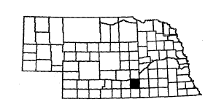
Communities Served:
Ayr
Hastings
Holstein
Juniata
Kenesaw
Prosser
Roseland

Contact: Ardella Rold
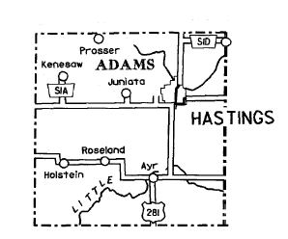
Adams County Senior Services
509 South Bellevue
Hastings, NE 68901

Telephone: (402) 463-5681
Fax: (402) 463-6971

Nebraska Association of Transportation Providers member

Description of System: The Adams County System is a demand-response, portal-to-portal service with a requested 24-hour advance reservation in Hastings. Outlying county areas are served with a requested 24-hour advance reservation. Trips are scheduled to the mall on Mondays at 2:00 p.m. and Fridays at 10:00 a.m. and 2:00 p.m. Trips are scheduled to Wal-Mart on Mondays at 9:00 a.m. or 2:00 p.m.

Days and Hours of Operation:
Monday through Friday, 8:00 a.m. – 5:00 p.m.
Mondays – Service is provided to Kenesaw regularly.
Outlying areas in county are served on a request basis.

Rate Schedule:
10-ride pass for $12.00
Without pass - $1.25 per one-way ride

Number of Vehicles:
Three 11-passenger small buses, lift equipped
One 6-passenger minivan
One 16-passenger van (used as a back-up vehicle)
Antelope County

Rural Public Transportation – City of Neligh Dial-A-Ride
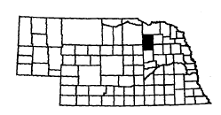
Communities Served:
Elgin
Neligh
Oakdale

Contact: Elaine Hamm
City Clerk
P.O. Box 87
Neligh, NE 68756
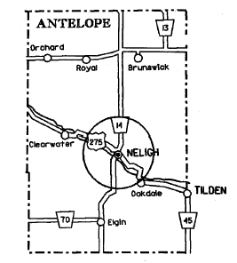

Telephone: City Office (402) 887-4066
Dial-A-Ride (402) 887-4225
Fax: (402) 887-5343

Nebraska Association of Transportation Providers member

Description of System: One bus, lift-equipped, seating 11 passengers and one van. Service is on a demand basis by schedule at the City Office as listed below. Service is mainly within Neligh, but extends to outlying areas of Antelope County. Other towns served on a regular basis, on school contracts are Oakdale and Elgin. Children are transported to the Trainable Handicapped School on a regular schedule during the school year. Service is available in Neligh on Sunday to church.

Days and Hours of Operation:
September through May
Monday through Friday
9:00 a.m. – Noon and 1:00 p.m. to 5:00 p.m.

June through August
Monday, Wednesday and Friday
9:00 a.m. – Noon and 1:00 p.m. – 5:00 p.m.

All Year, Every Sunday
8:30 a.m. – Noon

Rate Schedule:
$1.00 per one-way trip, plus 37.5 cents per mile outside of Neligh city limits.

Number of Vehicles:
1 small bus, lift equipped
1 van
Boone County

Rural Public Transportation – Wolf Memorial Good Samaritan Center
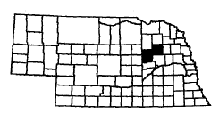
Communities Served:
Albion Loretto
Boone Newman Grove
Cedar Rapids Petersburg
Lindsay St. Edward

Contact: Haley Hunhoff
Wolf Memorial Samaritan Center
1222 South 7th Street
Albion, NE 68620

Telephone: (402) 395-5050
Fax: (402) 395-2303

Nebraska Association of Transportation Providers member
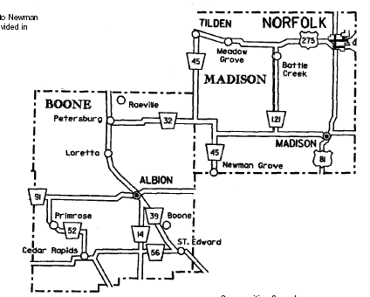

Description of System: Dial-a-ride service for all of Boone County, Newman Grove, and Lindsay.

Days and Hours of Operation:
Monday through Friday
8:00 a.m. – 3:00 p.m.
No holidays or weekends

Rate Schedule:
$.50 each way
$.40 per mile out of town
$10 per hour waiting fee

Number of Vehicles:

1 bus, lift-equipped
1 minivan, lift-equipped

Box Butte County

Rural Public Transportation – Box Butte County Handi Bus Program
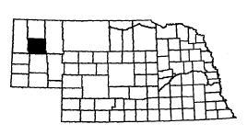
Communities Served:
Alliance
Hemingford

Contact: Ms. Bayone Meyer
Senior Services, Inc.
212 Yellowstone
Alliance, NE 69301
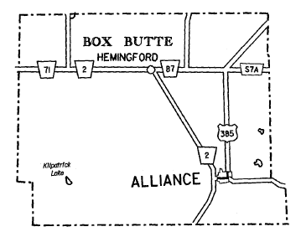
Telephone: (308) 762-3596

Nebraska Association of Transportation Providers member

Description of System: The Box Butte County Handi Bus service is available in Alliance and Hemingford Monday through Friday from 7:15 a.m. to 4:30 p.m. This service is open to the general public, elderly and disabled. There is no set fare for this service, but contributions are appreciated.

Days and Hours of Operation:
January through December
Monday through Friday, 7:15 a.m. – 5:30 p.m.

Rate Schedule:
$1.00 per round trip other than congregate meals
$0.50 per round trip to congregate meals

General Public
$1.00 per round trip

Number of Vehicles:
Four 12-15-passenger vans, all lift-equipped
Buffalo County

Rural Public Transportation – Buffalo County Public Transportation
R.Y.D.E. Transit (Reach Your Destination Easily)

Communities Served:
Amherst Pleasanton
Elm Creek Poole
Gibbon Ravenna
Kearney Riverdale
Miller Shelton
Odessa

R.Y.D.E. Contact: Jeffrey Rumery, CCTM, Transit Manager
Community Action Partnership of Mid-Nebraska
16 W. 11th St.
P.O. Box 2288
Kearney, NE 68848

Telephone: (308) 865-5677 Web: www.mnca.net
Fax: (308) 865-1358 E-mail: jrumery@mcna.net

Nebraska Association of Transportation Providers member
Heartland ITS
Community Transportation Association of America member
Governors Transportation Access Working Group

Description of System: R.Y.D.E. Transit, operated by Community Action Partnership of Mid-Nebraska serves Buffalo County with demand responsive, portal-to-portal service, Monday through Friday in Kearney and scheduled weekly service to towns in Buffalo County. Service should be scheduled 24 hours in advance, rides scheduled less than 24 hours in advance are on an as available basis. R.Y.D.E. Transit also has discounted tickets for Kearney Cab Company, to be used when R.Y.D.E. service is unavailable in Kearney.

Days and Hours of Operation:
Kearney:
Monday through Friday, 6:00 a.m. to 6:00 p.m.
Riverdale, Amherst, Miller:
Tuesdays 10:00 a.m. to 2:00 p.m.
Gibbon and Shelton:
Thursdays 10:00 a.m. to 2:00 p.m.
Elm Creek and Odessa:
Fridays 10:00 a.m. to 2:00 p.m.
Pleasanton, Poole and Ravenna: On demand, as available

Rate Schedule:

In Kearney, one way: $1.00
Cab tickets: $2.50
Out of town, scheduled, one way: $1.50
Out of town, non-scheduled out of town: from $7.00

Number of Vehicles:
Twelve 12-passenger buses, lift equipped
One 9-passenger van, lift equipped
Two 15-passenger vans, no lift
Buffalo County

Rural Public Transportation – City of Ravenna Public Transportation

Communities Served:
Ravenna St. Paul
Loup City Pleasanton
Kearney Cairo

Contact: Patsy Clausen
107 W. Genoa St.
Ravenna, NE 68869

Telephone: (308) 452-3142 Web: www.mnca.net
Fax: (308) 865-1358 E-mail: jrumery@mcna.net

Nebraska Association of Transportation Providers member
Heartland ITS
Community Transportation Association of America member
Governors Transportation Access Working Group

Description of System: The City of Ravenna Public Transportation, operated by Community Action Partnership of Mid-Nebraska, serves the City of Ravenna with demand responsive, portal to portal service, Monday through Friday in Ravenna and scheduled weekly service to towns in and around Buffalo County. Service should be scheduled 24 hours in advance, rides scheduled less than 24 hours in advance are on an as available basis.

Days and Hours of Operation:
Monday: 8:30 a.m. to Noon Ravenna service
1:00 p.m. to 5:00 p.m. Ravenna to Loup City
Tuesday: 8:30 a.m. to 5:30 p.m. Ravenna service
Wednesday: 8:30 a.m. to Noon Ravenna service
1:00 p.m. to 5:00 p.m. Ravenna to Kearney or Ravenna service
(On alternate weeks)
Thursday: 8:00 a.m. to Noon Ravenna service
1:00 p.m. to 5:00 p.m. Ravenna to Grand Island and return
Friday: 8:00 a.m. to Noon Ravenna service
1:00 p.m. to 5:00 p.m. Ravenna to Kearney and return

Rate Schedule:
In town, one way: $0.50 Out of town, scheduled, one way: $1.00

Number of Vehicles:
One 9-passenger van, lift-equipped
Burt County

Rural Public Transportation – Oakland Transportation System
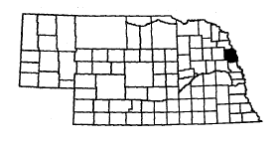
Contact: Dee Bailey
Oakland Heights
207 South Engdahl
Oakland, NE 68045

Telephone: (402) 685-5683
Fax: (402) 685-5684
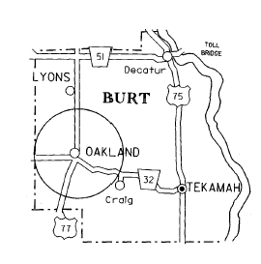
Nebraska Association of Transportation Providers member

Description of System: The Oakland Transportation System provides demand-responsive service within the city limits of Oakland five days a week Monday through Friday. Available for doctor’s appointments to Fremont, West Point and Tekamah by prior arrangement.

Days and Hours of Operation:
Monday through Friday
8:00 a.m. to 4:00 p.m.

Rate Schedule:
$1.00 per boarding in Oakland.
For out of town trips, 35 cents/mile plus $10/hour.

Number of Vehicles:
1 van, lift-equipped
Butler County

Rural Public Transportation – Butler County Senior Services Program

Communities Served:
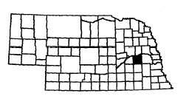
Abie Linwood
Bellwood Loma
Brainard Octavia
Bruno Rising City
David City Surprise
Dwight Ulysses
Garrison
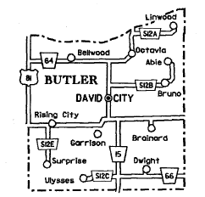
Contact: Judy Polacek
Manager
Butler County Senior Services Program
592 “D” Street
David City, NE 68632

Telephone: (402) 367-6131
Fax: (402) 367-4073
E-Mail bcssp@navix.net

Nebraska Association of Transportation Providers member

Description of System: The Butler County Transit system provides demand-response service to all communities and rural areas within Butler County. Service is provided five days a week, Monday through Friday. Reservations are required 24 hours in advance.

Days and Hours of Operation: Monday through Friday, 8:30 a.m. – 4:30 p.m.

Monday: Service is available fro trips from Brainard, Dwight, Garrison, Loma, Rising City, Surprise and Ulysses to David City.
Wednesday: Service is available for trips from Abie, Bruno, Bellwood, Linwood and Octavia to David City.
Friday: Service is available to all of the county upon request.
Tuesday and Thursday: Trips are made on alternate Tuesdays and Thursdays to communities of Columbus, Fremont, Lincoln, Omaha, Seward, Wahoo and Schuyler.

Rate Schedule:

One-Way Trip Fee
Local | $2.00
Within 10 miles of David City | $2.50
Beyond 10 miles of David City | $3.00
Trips to Columbus, Wahoo and Seward | $4.00
Trips to Lincoln | $4.50
Trips to Omaha | $5.00
Local wheelchair | $2.50
Number of Vehicles:
1 van, lift-equipped

Cedar County

Rural Public Transportation – Cedar County Transit-Bus
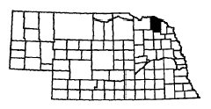
Communities Served:
Belden Magnet
Bow Valley Menominee
Coleridge Obert
Fordyce Randolph
Hartington St. Helena
Laurel Wynot

Contact: Dave Dowling
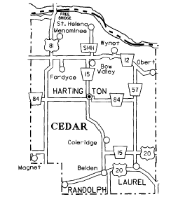
Cedar County Transit-Bus
Box 47
Hartington, NE 68739

Telephone: Ann M. Lentz (402) 254-6668
Fax: (402) 254-6954

E-mail Cedarclk@hartel.net

Nebraska Association of Transportation Providers member

Description of System: The Cedar County Transit-Bus provides transportation to all communities in Cedar County five days per week on a demand-response and portal-to-portal basis. On Tuesdays and Thursdays, the bus services Hartington, Coleridge, Laurel, Belden, Randolph, and Magnet. The bus also runs to Osmond on Thursdays for hospital or other medical purposes. On Wednesdays, the bus services Hartington, Fordyce, Menominee, Bow Valley, St. Helena, Obert and Wynot. On a regular basis (Mondays and Fridays) the system provides Cedar County residents transportation to Yankton, South Dakota, Sioux City, Iowa and Norfolk, Nebraska. As required, the system provides transportation to Omaha, Nebraska for medical consultation.

Days and Hours of Operation: Monday through Friday, 8:00 a.m. – 5:00 p.m.

Rate Schedule: General Public:
$1.00 per one-way trip within the community
$2.00 per one-way trip community-to-community
$2.50 per one-way trip outside Cedar County

$0.40 per mile charter trip

Service is not based on ability to pay. All persons
in Cedar County are provided transportation

Number of Vehicles:
One 12 plus 2 wheelchair passengers

Chase County

Rural Public Transportation – Chase County Transit Service
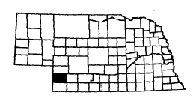
Communities Served:
Champion
Enders
Imperial
Lamar
Wauneta

Contact: Dawn Wheeler
Chase County Transit Service
9th & Wellington
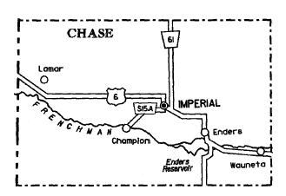
P.O. Box 639
Imperial, NE 69033

Telephone: (308) 882-5130 – Imperial
(308) 394-5287

Nebraska Association of Transportation Providers member

Description of System: The Chase County transportation system is a demand-responsive transportation service serving all of Chase County. Imperial service is provided Monday through Friday 8:00 a.m. to 4:00 p.m. Wauneta service is currently Tuesday, Wednesday and Thursday 8:00 a.m. to 4:00 p.m. Wauneta service will be expanding as demand increases in the future. Reservations are requested 24 hours in advance.

Days and Hours of Operation: Monday through Friday, 8:00 a.m.-4:00 p.m.

Rate Schedule: Round trip $1.00

Number of Vehicles:
2 buses, both lift-equipped

Cheyenne County

Rural Public Transportation – City of Sidney Transportation System

Contact: Jim Benzel
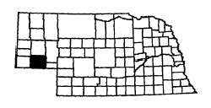
City of Sidney
P.O. Box 79
Sidney, NE 69162

Telephone: (308) 254-5300
(308) 254-7070
Fax: (308) 254-3164

Nebraska Association of Transportation Providers member
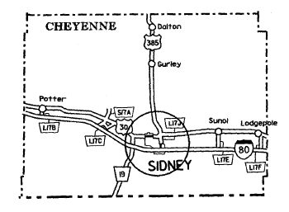

Description of System: The City of Sidney Transportation System is a demand-responsive system operating and providing service to the citizens in the area. The system operates Monday through Friday.

Days and Hours of Operation:
Monday through Friday
8:00 a.m. – 4:00 p.m.

Rate Schedule:
Elderly-Disabled
$0.50 per one-way trip within city limits
Plus $0.25 per mile over the first 2 miles

General Public
$1.00 per one-way trip within city limits
Plus $0.25 per mile over 2 miles
$1.00 per one-way trip for Day Care Children
Outside city limits – negotiated with Coordinator

Number of Vehicles:
1 bus, lift-equipped
Clay County

Rural Public Transportation – Midland Area Agency on Aging
Clay County HandyBus
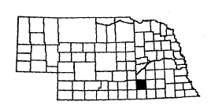
Communities Served:
Clay Center Inland
Deweese Ong
Edgar Saronville
Fairfield Sutton
Glenvil Trumbull
Harvard

Contact: Clay County
Clay County Senior Services
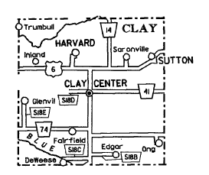
205 West Fairfield Suite 1
Clay Center, NE 68933

Telephone: (402) 762-3226
Fax: (402) 762-3892

Nebraska Association of Transportation Providers member

Description of System: Service is available Tuesday, Thursday and Friday as needed. Trips must be scheduled by noon the day before the bus runs. This is a countywide service with trips to Geneva, Henderson, Nelson, Aurora, Hastings, Superior and Sutton

Days and Hours of Operation:
Tuesday, Thursday and Friday
(except on holidays)
8:00 a.m. – 5:00 p.m.

Rate Schedule:
Elderly - Disabled
$6.00 round trip

General Public
$10.00 round trip

Number of Vehicles:
1 van, lift-equipped
Colfax County

Rural Public Transportation – City of Schuyler Handi Bus
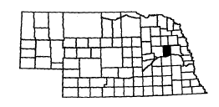
Contact: Gail Fickle
Colfax County Senior Citizen Center
124 East 12th Street
Schuyler, NE 68661

Telephone: (402) 352-5008
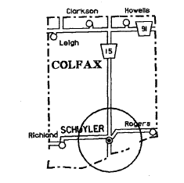
Nebraska Association of Transportation Providers member

Description of System: The transit system is demand-response operating within the city limits of Schuyler, Monday through Friday. Trips are scheduled in advance.

Days and Hours of Operation:
Monday through Friday
9:00 a.m. – noon and 1:00 p.m. – 4:00 p.m.

Rate Schedule:
Elderly – Disabled
$1.00 per one-way trip

General Public
$2.00 per one-way trip

Number of Vehicles:
1 van, lift-equipped

Custer County

Rural Public Transportation – City of Broken Bow Handi Bus

Communities Served:
Anselmo Callaway Oconto
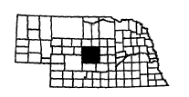
Ansley Comstock Sargent
Arnold Gates Weissert
Berwyn Mason City Westerville
Broken Bow Merna

Contact: Elaine Bayer
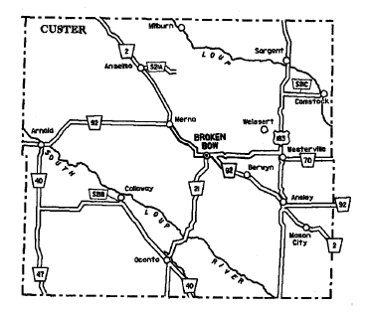
City Clerk
P.O. Box 504
Broken Bow, NE 68822

Telephone: (308) 872-6609
Fax: (308) 872-0075

Nebraska Association of Transportation Providers member

Description of System: The City of Broken Bow Handi Bus provides service five days a week, Monday through Friday, and covers all of Custer County on a demand-responsive basis.

Days and Hours of Operation:
Monday through Friday:
8:00 a.m. – 12:00 p.m. and 1:00 p.m. – 5:00 p.m.

Monday: Westerville, Ansley, Berwyn, Mason City and Broken Bow
Tuesday: Gates, Weissert, Comstock, Sargent and Broken Bow
Wednesday: Callaway, Oconto and Broken Bow
Thursday: Merna, Anselmo, Arnold and Broken Bow
Friday: Broken Bow (all day)

Rate Schedule: Contributions

Number of Vehicles:
1 van, lift-equipped

Dakota County

Rural Public Transportation – Sioux City Transit System

Contact: Curt Miller Lance Hedquist
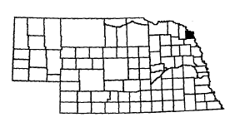
Transit Director City Administrator
2505 4th Street 1615 First Avenue
Sioux City, IA 51105 South Sioux City, NE 68776

Telephone: (712) 279-6405 (402) 494-7515
Fax: (712) 279-6407
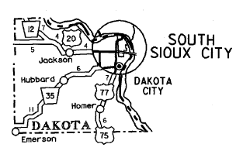

Description of System: The Sioux City Transit System provides service to the Sioux City urban area on a regular route schedule basis. This system provides service Monday through Saturday, and no vehicle operation Sundays. Paratransit service is provided through contracted carriers, operating a demand-response basis during the same timeframe as the Sioux City Transit System. South Sioux City has a dedicated route that has been planned in such a way that it provides service within five blocks of a majority of all city households. The route also serves several city schools during weekday mornings and afternoons.

Days and Hours of Operation:
Monday through Friday: 6:00 a.m. – 6:00 p.m.
Saturday: 7:00 a.m. – 6:00 p.m.

Rate Schedule:
Adult Cash Fare | $ 1.50
Adult Monthly Pass | $40.00
Tokens | 20 for $25.00
Weekly Ticket | $15.00
Student Ticket | $12.50
Senior Citizen 10-ride ticket | $ 7.50
Disabled 10-ride ticket | $ 7.50
Senior Citizen/Disabled Monthly | $35.00
Senior Citizen/Disabled Cash | $ .75 (Only from 9:00 a.m. – 3:00 p.m.)
Youth Cash Fare | $ 1.25 (Only from 9:00 a.m. – 3:00 p.m.)
Children Under 5 | Free (Accompanied by an adult)
Transfer | Free

Number of Vehicles:
Two 43-passenger buses, lift-equipped
Six 35-passenger buses
One 43-passenger bus
One 35-passenger bus, lift-equipped
Four 22-passenger buses, ramp-equipped
One 39-passenger trolley
One 42-passenger trolley
Two 27-passenger buses, lift-equipped
Two 24-passenger buses, ramp-equipped
One paratransit mini-van, ramp-equipped
Two 21-passenger paratransit maxi-bus, lift-equipped
Two 20-passenger paratransit maxi-bus, lift-equipped
Two 16-passenger paratransit maxi-bus, lift-equipped
Dawes County

Rural Public Transportation – City of Chadron Handi Bus
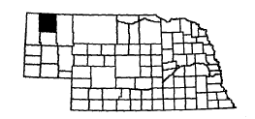
Contact: Jerry Crews
Chief of Police
125 Main
Chadron NE 69337

Telephone: (308) 432-0520
Fax: (308) 432-0513
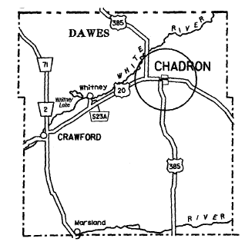
Nebraska Association of Transportation Providers member

Description of System: The City of Chadron Handi Bus provides transportation services for the entire city within the corporate limits. The bus is in operation from 8:30 a.m. to 4:30 p.m., Monday through Friday. The system is demand-responsive.

Days and Hours of Operation:
Monday through Friday:
8:30 a.m. – 4:30 p.m.

Rate Schedule:
Contributions

Number of Vehicles:
1 van
1 small bus, lift-equipped

Dawes County

Rural Public Transportation – Crawford Public Transportation
Communities Served:
Belmont
Crawford
Glen
Marsland
Whitney

Contact: Billi Junge, Bus Driver
Sandy Seidel, City Clerk
209 Elm Street
Crawford, NE 69339

Telephone: (308) 665-1256, Public Transportation
(308) 665-1462, City Clerk
Fax: (308) 665-2441, City Hall
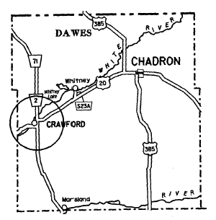

Nebraska Association of Transportation Providers Member

Description of System: The Crawford Public Transportation Department provides demand-responsive service, Monday through Friday, to Crawford, Whitney, Marsland, Harrison, and surrounding rural areas. Once a week, a trip is made to Chadron. Once a month, a trip is made to Scottsbluff. Once a month, a trip is made to Rapid City, South Dakota with a 4-person minimum.

Days and Hours of Operation:
Monday through Friday:
8:00 a.m. – Noon and 1:00 p.m. – 5:00 p.m.

Rate Schedule:
25 cents per boarding within Crawford
$5.00 per round trip to Chadron, Harrison, Whitney, Marsland, Glen and Belmont for only one person
$2.50 per round trip to Chadron, Harrison, Whitney, Marsland, Glen and Belmont for more than one person
$24.00 per round trip to Scottsbluff for only one person
$12.00 per round trip to Scottsbluff for two people
$8.00 per round trip to Scottsbluff for three people
$9.00 per round trip to Rapid City, South Dakota for four people (minimum)

Number of Vehicles:
1 van, lift-equipped
Dawson County

Rural Public Transportation – Dawson County Handi Bus

Communities Served:
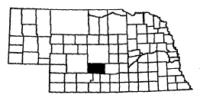
Cozad | Lexington
Eddyville | Overton
Farnam | Sumner
Gothenburg

Contact: Barbara R. Lind Hollenbeck, Director
Dawson County Handi Bus
P.O. Box 279
Lexington, NE 68850

Telephone: (308) 324-3670
Fax: (308) 324-3670

Nebraska Association of Transportation Providers member
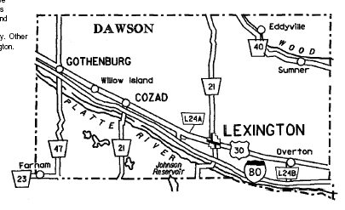

Description of System: The Dawson County Handi Bus provides demand-responsive service Monday through Friday to the residents of Dawson County: Morning service is provided in Lexington each Wednesday in addition to full day service on Monday and Friday. Tuesday service is provided in Farnam and Gothenburg. The first and third Wednesday service is provided to Eddyville, Sumner, and Overton for trips to Kearney. Other Wednesday service is provided to Eddyville, Sumner, and Overton for trips to Lexington. Cozad is provided service on Thursday.

Days and Hours of Operation:
Monday through Friday:
8:00 a.m. – Noon and 1:00 p.m. – 5:00 p.m.

Rate Schedule:
$1.00 per one-way trip out of town for one stop, $2.00 round trip
$2.00 per one-way trip from Lexington to Kearney
$3.00 per round way trip from Lexington to Kearney

Number of Vehicles:
2 buses, lift-equipped
Deuel County

Rural Public Transportation – Deuel County Mini Bus
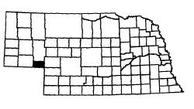
Communities Served:
Big Springs
Chappell
Lodgepole

Contact: Beverly Graves
Administrator
Chappell Senior Citizens
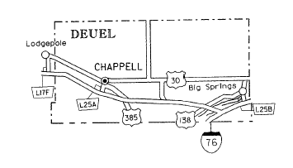
PO Box 241
Chappell, NE 69129

Telephone: (308) 874-2438

Nebraska Association of Transportation Providers member

Description of System: This is a demand-responsive system providing service to Deuel County and Lodgepole, Monday through Friday, with some service on Saturday as needed. The system makes trips outside of Deuel County to Sidney, Ogallala, Oshkosh, North Platte and Scottsbluff, Nebraska, Julesburg and Sterling, Colorado and Cheyenne, Wyoming. Mini-bus trips once a month.

Days and Hours of Operation:
Monday through Friday, 8:00 a.m. – 5:00 p.m.

Rate Schedule:
Elderly – Disabled
$1.00 round trip in Chappell

General Public (under 60)
$2.00 round trip in Chappell

Number of Vehicles:
1 bus, lift-equipped, 2 wheelchairs
1 van, lift-equipped, 1 wheelchair
1 Astro van, 5-passenger

Dixon County

Rural Public Transportation – Wakefield Public Transportation Program

Community Served:
Wakefield

Contact: Peggy Bressler, Manager
Wakefield Senior Center
20 Johnson St.
P.O. Box 130
Wakefield, NE 68784

Telephone: (402) 287-2149
Fax: (402) 287-2149
E-mail: waksrctr@huntel.net

Nebraska Association of Transportation Providers member

Description of System: Wakefield Transportation System covers Wakefield address population on a demand basis or for out of town. Trips by advance appointment at the Wakefield Senior Citizens Center. Two vans, one seating 6 and one seating 7 passengers.

Days and Hours of Operation:
Monday through Friday: 8:00 a.m. – 4:00 p.m.

Rate Schedule:
Local: $ .50 one way per round trip

Out of Town: $ 5.00 – Emerson, Pender, Wayne
$10.00 – Sioux City, Norfolk
$15.00 – Omaha, Yankton, Lincoln

Number of Vehicles:
2 vans

Dodge County

Rural Public Transportation – Fremont Transit Line

Contact:
Operational | Financial/Budget
Mark Vyhlidal | Randy Reyzlik
Superintendent of Public Services | City Administrator
P.O. Box 1266 | P.O. Box 1266
Fremont, NE 68026-1266 | Fremont, NE 68026-1266
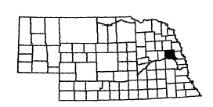

Telephone: (402) 727-2690
Fax: (402) 727-2667

Nebraska Association of Transportation Providers member

Description of System: The Fremont Transit Line is a city-owned and operated fixed route system. There are two routes with each route commencing every two hours of operation from the origination point at 6th and Main Street.
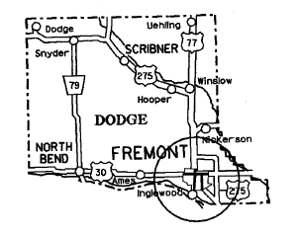

Days and Hours of Operation:
Monday through Saturday:
8:50 a.m. – 4:30 p.m.
(Does not operate on Sundays)

Rate Schedule:
Elderly – Disabled
$0.75 per one-way trip

General Public
$1.50 per one-way trip
Children under six ride free

Number of Vehicles:
2 small buses, lift-equipped

Douglas County

Rural Public Transportation – Eastern Nebraska Office on Aging
Transportation System (ENOA)
Communities Served:
Alvo Gretna Snyder
Arlington Herman South Bend
Bennington Hooper Springfield
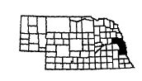
Blair Kennard Uehling
Cedar Creek Louisville Valley
Dodge Manley Washington
Eagle Murdock Waterloo
Elkhorn Murray Weeping Water
Elmwood North Bend Winslow
Fort Calhoun Plattsmouth Scribner
Fremont
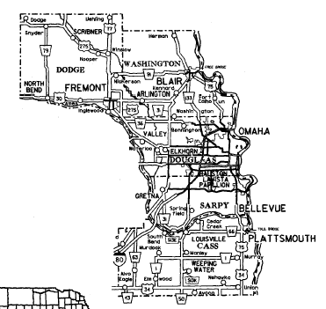

Contact: Beverly Griffith, Director
Eastern Nebraska Office on Aging
4223 Center St.
Omaha, Nebraska 68105

Telephone: Douglas, Sarpy and
Cass County residents:
(402) 994-2406 or
1-888-210-1093
Dodge County residents:
(402) 721-7770
Washington County residents:
(402) 426-9614
Fax: (402) 444-6503

Nebraska Association of Transportation Providers member

Description of System: This is a demand-responsive system operating Monday through Friday. This service is limited to rural areas of Cass, Dodge, Douglas, Sarpy and Washington Counties. ENOA will not provide transportation services to residents of Avoca and Union. Services there are maintained by the Blue Rivers Area Agency on Aging.

Days and Hours of Operation: Monday through Friday: 8:00 a.m. – 4:00 p.m.
Special pickup times prior to 8:00 a.m. may be arranged

Rate Schedule: Elderly – Disabled
0-10 miles, $2.00 one way/ $ 4.00 round trip
11-20 miles, $4.00 one way/ $ 8.00 round trip
21-40 miles, $5.00 one way/ $10.00 round trip
41-60 miles, $6.00 one way/ $12.00 round trip
61+ miles, $7.00 one way/ $14.00 round trip

General Public
$9.00 one way/ $18.00 round trip

Number of Vehicles:
4 vans, lift-equipped
2 mini vans
Dundy County

Rural Public Transportation – City of Benkelman Handi Bus
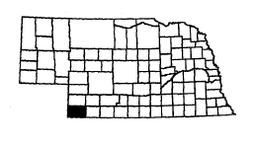
Communities Served:
Benkelman
Haigler
Max
Parks

Contact: Cherry Carter
Dundy County Senior Services, Inc.
P.O. Box 409
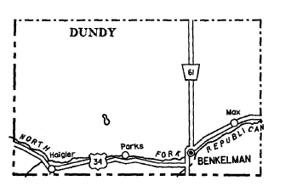
Benkelman, NE 69021

Telephone: (308) 423-5454

E-Mail: dcseniors@bwtelcom.net

Nebraska Association of Transportation Providers member

Description of System: The City of Benkelman Handi Bus is a demand-responsive service operating Monday through Friday. It provides service to Benkelman, Parks, Max and Haigler.

Days and Hours of Operation:
Monday through Friday
May 15th through August 15th, 9:00 a.m. – 3:00 p.m.
August 16th through May 14th, 8:30 a.m. – 3:30 p.m.

Rate Schedule:
$0.50 per boarding within Benkelman
$0.20 per mile from Parks, Max or Haigler to Benkelman

Number of Vehicles:
1 bus, lift-equipped

Fillmore County

Rural Public Transportation – Fillmore County Rural Transit Service
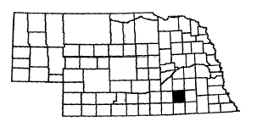
Communities Served:
Exeter Grafton Shickley
Fairmont Milligan Strang
Geneva Ohiowa

Contact: Jane Cronk
Manager/Dispatcher
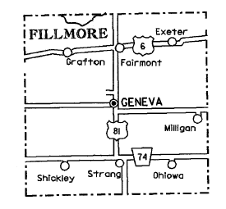
1120 “F” Street
Geneva, NE 68361

Telephone: (402) 759-3345
Fax: (402) 759-3690

Nebraska Association of Transportation Providers member

Description of System: The Fillmore County Transportation System covers all of the county on a demand-response basis. Monday through Friday service is provided in the City of Geneva. Towns in the County have service to Geneva at least one day a week. One trip per week to Lincoln and monthly trips to Hastings, York and Grand Island are regularly scheduled. Printed schedules are available upon request. For out-of-county trips, advanced reservation is necessary.

Days and Hours of Operation:

Monday through Friday: | City of Geneva, 8:00 a.m. – 4:00 p.m.
Tuesday: | Trip to Lincoln, Hastings, York or Grand Island  Fairmont and Exeter to Geneva
Wednesday: | Milligan and Ohiowa to Geneva
Thursday: | Trip to Lincoln, Hastings, York or Grand Island  Shickley and Strang to Geneva
Friday: | Grafton, Fairmont and Exeter to Geneva

Rate Schedule:
Local (within city limits): $0.75 per one-way trip
Intercounty (one community to another) $1.50 per one-way trip
Area I (less than 20 miles from county) $3.00 per one-way trip
Area II (Lincoln, Hastings and Grand Island) $3.75 per one-way trip

Number of Vehicles:
1 van, lift equipped
1 station wagon
1 minivan
Franklin County

Rural Public Transportation – Franklin County Public Transportation

Communities Served:
Franklin Bloomington Hildreth
Naponee Riverton
Upland Campbell

Contact: Carol Yelken
621 15th Ave.
P.O. Box 263
Franklin, NE 68939-0263

Telephone: (308) 425-3724 Web: www.mnca.net
Fax: (308) 865-1358 E-mail: jrumery@mcna.net

Nebraska Association of Transportation Providers member
Heartland ITS
Community Transportation Association of America member
Governors Transportation Access Working Group

Description of System: Franklin County Public Transportation, operated by Community Action Partnership of Mid-Nebraska, serves Franklin County with demand responsive, portal-to-portal service, Monday through Friday in Franklin and scheduled weekly service to towns in Franklin County. Service should be scheduled 24 hours in advance, rides scheduled less than 24 hours in advance are on an as available basis.

Days and Hours of Operation:

Monday: Bus 1 Service to Franklin, Bloomington and Naponee
Bus 2 Service to Kearney or Hastings
Tuesday: Bus 1 Service to Franklin and Riverton
Bus 2 Service to Naponee, Bloomington, Franklin and Minden
Wednesday: Bus 1 Service to Bloomington, Naponee, Riverton and Franklin
Bus 2 Service to Upland, Campbell and Franklin
Thursday: Bus 1 Service to Riverton, Naponee, Bloomington and Franklin
Bus 2 Service to Upland, Hildreth and Minden
Friday: Bus 1 Service to Naponee, Bloomington and Franklin
Bus 2 Service to Kearney or Hastings

Rate Schedule:
In town, one way: 50 cents Out of town, scheduled, one way: $1.00

Number of Vehicles:
One 9-passenger van, lift equipped
One 7-passenger mini-van, no lift

Furnas County

Rural Public Transportation – Tri Valley Handi Bus

Communities Served:
Arapahoe Hendley
Bartley Holbrook
Beaver City Indianola
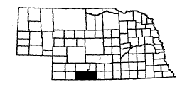
Cambridge Oxford
Edison Wilsonville

Contact: Diana Gross
Tri Valley Health System
P.O. Box 488
Cambridge, NE 69022
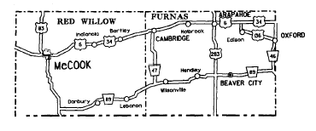
Telephone: (308) 697-3329
(308) 697-4236
Fax: (308) 697-4918

Nebraska Association of Transportation Providers member

Description of System: The transit system provides demand-responsive service to the communities of Cambridge, Wilsonville, Hendley, Beaver City, Arapahoe, Edison, Oxford, Indianola, Bartley and Holbrook.

Days and Hours of Operation:
Tuesday through Friday: 8:00 a.m. – 5:00 p.m.
Trips are scheduled as requested.

Rate Schedule:
$0.50 per one-way, in town

Out-of-town | Round trip
<26 miles | $5.00
26-40 | 7.25
41-50 | 10.00
51-60 | 12.00
>60 miles | $0.20/mile + $1.00/hour

Number of Vehicles:
1 van, lift-equipped
Gage County

Rural Public Transportation – Blue Rivers Transportation System
Communities Served:

Adams | Ellis | Lanham | Rockford
Beatrice | Filley | Odell | Virginia
Clatonia | Harbine | Pickrell | Wymore
Cortland | Holmesville | Plymouth

Contact: Ruth Bartholomew/Lorene Fielder

Blue Rivers Area
Agency on Aging
Room 24, Courthouse
612 Grant St.
Beatrice, NE 68310

Telephone: (402) 223-1357 or
1-800-659-3978
Fax: (402) 228-3546

Nebraska Association of Transportation Providers member

Description of System: The Blue Rivers Transportation System operates in Gage County of southeast Nebraska on a demand-response, portal-to-portal, 24-hour advance reservation basis. Vehicles are stationed in Beatrice. Surrounding communities routes are scheduled on an as needed, once a week basis. BRAAA contracts with a private taxi company in Beatrice for off-hour or peak-time transportation service. Intercity (west) routes provide transportation to Lincoln 3 days per week.

Days and Hours of Operation:
Monday through Friday: 8:00 a.m. – Noon and 12:30 p.m. – 4:30 p.m.
Route times 8:00 a.m. to 10:00 a.m. and return 3:00 p.m. to 4:15 p.m. as requested
Monday: Service from Beatrice to DeWitt, Plymouth and return to Beatrice
Tuesday: Service from Beatrice to Clatonia, Cortland, Adams, Pickrell and return to Beatrice
Wednesday: Service from Beatrice to Ellis, Harbine, Diller, Lanham, Odell and return to Beatrice
Thursday: Service from Beatrice to Wymore and return to Beatrice
Friday: Service from Beatrice to Rockford, Filley, Virginia, Holmesville and return to Beatrice.
Vans will run routes on needed basis only. Second van will run Monday through Friday, service in Beatrice 8:00 a.m. to 4:30 p.m.
Connects with intercity western route on Mondays, Wednesdays and Thursdays, for trips to Lincoln.

Rate Schedule:
$1.25 per one-way trip within a community
$2.50 per one-way trip between communities
$6.00 per one-way trip to Lincoln, Omaha, and Hastings
$2.25 per one-way trip – taxi contract within city limits

Number of Vehicles:
Three 11-passenger vans, with lifts

Gage County (Southern)

Rural Public Transportation – Blue Rivers Transportation System
Communities Served:

Barneston | Beatrice | Blue Springs | Liberty
Wymore

Contact: Larry Ossowski, Director
Blue Rivers Area Agency on Aging
Room 24, Courthouse
612 Grant St.

Beatrice, NE 68310
Local Contact: Lois Milburn in Wymore

Telephone: (402) 645-3525

Nebraska Association of Transportation Providers member

Description of System: The Blue Rivers Transportation System operates in southern Gage County of southeast Nebraska on a demand-response, portal-to-portal, 24-hour advance reservation basis. Vehicle is stationed at Wymore. Routes are scheduled daily to Blue Springs, Barneston, and Liberty, on an as needed basis. Weekly route to Beatrice. This route also connects with Inter-City (West) for trips to Lincoln.

Days and Hours of Operation:
Monday through Friday: 8:00 a.m. – Noon and 1:00 p.m. – 5:00 p.m.
Tuesday through Friday: 9:00 a.m. – Noon and 1:00 p.m. – 4:00 p.m.
Monday through Friday: van in Blue Springs and Wymore except routes times,
9:30 a.m. – 11:00 a.m. and return route 2:00 p.m. to 3:30 p.m.
Monday through Friday: Wymore to Barneston and Liberty and return to Wymore as requested.
Every Monday: Wymore to Beatrice to connect with intercity van to Lincoln.

Rate Schedule:
$1.25 per one-way trip within a community
$2.50 per one-way trip between communities
$6.00 per one-way trip to Lincoln, Omaha, and Hastings

Number of Vehicles:
One 11-passenger van with lift

Garfield County

Rural Public Transportation – Burwell Community Memorial
Health Center

Communities Served:
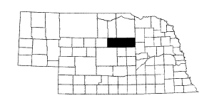
Bartlett
Burwell
Taylor
Ericson

Contact: Lisa Woitalewicz
P.O. Box 340
Burwell, NE 68823

Telephone: (308) 346-4440 or (308) 942-3185
Fax: (308) 346-5184

Nebraska Association of Transportation Providers member

Description of System: The transportation system provides demand-responsive service to Loup, Garfield and Wheeler Counties.

Days and Hours of Operation:
Monday through Friday:
9:00 a.m. – 5:00 p.m.

Rate Schedule:
Due to possible rate restructure, contact the transportation system for rates.

Number of Vehicles:
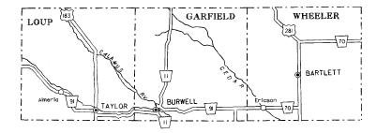
1 van, lift-equipped
1 car
1 bus, lift-equipped

Gosper County

Rural Public Transportation – Gosper County Public Transportation

Communities Served:
Elwood Johnson Lake
Smithfield Holdrege
Lexington

Contact: Janice Schmeeckle
Gosper County Courthouse
P.O. Box 101
Elwood, NE 68937-0101

Telephone: (308) 785-2036 Web: www.mnca.net
Fax: (308) 865-1358 E-mail: jrumery@mcna.net

Nebraska Association of Transportation Providers member
Heartland ITS
Community Transportation Association of America member
Governors Transportation Access Working Group

Description of System: Gosper County Public Transportation, operated by Community Action Partnership of Mid-Nebraska, serves Gosper County with demand responsive, portal-to-portal service, Monday through Friday in Elwood and scheduled weekly service to towns in and around Gosper County. Service should be scheduled 24 hours in advance, rides scheduled less than 24 hours in advance are on an as available basis.

Days and Hours of Operation:
Monday: 1st Elwood and Smithfield to Kearney 8:00 a.m. to 5:00 p.m.
2nd Elwood Service 8:00 a.m. to Noon
3rd Elwood & Johnson Lake to Lexington 1:00 p.m. to 5:00 p.m.
4th Elwood Service 8:00 a.m. to Noon
Elwood and Smithfield to Lexington 1:00 p.m. to 5:00 p.m.
Tuesday: Elwood Service 8:00 a.m. to Noon
Elwood to Lexington 1:00 p.m. to 5:00 p.m.
Wednesday: Elwood Service 8:00 a.m. to Noon
Thursday: Elwood Service 8:00 a.m. to Noon
Friday: 1st Elwood Service 8:00 a.m. to Noon
2nd Elwood Service 8:00 a.m. to Noon
Elwood and Smithfield to Holdrege 1:00 p.m. to 5:00 p.m.
3rd Elwood Service 8:00 a.m. to Noon
4th Elwood Service 8:00 a.m. to Noon
Elwood and Smithfield to Holdrege 1:00 p.m. to 5:00 p.m.

Rate Schedule:
In town, one way: $0.50 Out of town, scheduled, one way: $1.00

Number of Vehicles:
One 9-passenger van, lift equipped
Grant County

Rural Public Transportation – Grant – Arthur Handi Bus
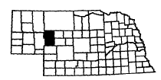
Communities Served:
Arthur
Ashby
Hyannis
Whitman

Contact: Tonchita J. Ring
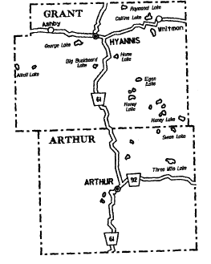
Grant County Clerk
Box 139
Hyannis, NE 69350-0139

Telephone: (308) 458-2488
Fax: (308) 458-2780

Nebraska Association of Transportation Providers member

Description of System: The Grant County Handi Bus provides demand-responsive service two days a week, Wednesdays and Fridays. Trips originate from Whitman, Hyannis, Ashby and Arthur to Ogallala on Wednesday. On Friday, trips are from Whitman, Hyannis and Ashby to Alliance.

Days and Hours of Operation:
Wednesdays & Fridays of each week, 8:00 a.m. – 5:00 p.m.

On Wednesday, the bus makes a trip to Alliance via Highway 2 and returns by the same route.

On Friday, the trip to Ogallala is made on Highway 61. The bus leaves the Grant County Courthouse about 8:00 a.m. and returns to Grant County around 5:00 p.m.

Rate Schedule:
Wednesdays to Alliance: $4.00
Fridays to Ogallala:
Arthur to Ogallala: $3.00
Hyannis to Ogallala: $4.00

Number of Vehicles:
1 van
Hall County

Rural Public Transportation – Hall County Public Transportation
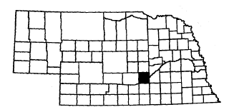
Communities Served:
Alda
Cairo
Doniphan
Grand Island
Wood River

Contact: Lorna Razey
Senior Citizens Industries
304 East 3rd
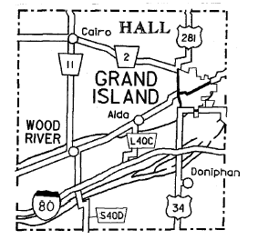
P.O. Box 1302
Grand Island, NE 68802

Telephone: (308) 385-5324
Fax: (308) 385-5312

E-Mail Hallcobus1@aol.com

Nebraska Association of Transportation Providers member

Description of System: The Hall County Public Transportation provides portal-to-portal service Monday through Friday. Service is limited to Hall County. It is requested that trips be scheduled a day in advance. Additional services are available to the elderly (60+) or disabled, registered bus riders for discounted Taxi Cab Tickets with the City Cab Company that operates 24 hours a day, seven days a week.

Days and Hours of Operation: Monday through Friday: 7:00 a.m. – 5:00 p.m.
We go to Alda, Cairo, Doniphan, Wood River, and Rural Hall County on a need to basis.

Rate Schedule:
Within Hall County $0.50 per one-way trip
Cab ticket $3.50 for a one-way taxi ride (within the Grand Island city limits)

Number of Vehicles:
4 buses, lift-equipped
Hamilton County

Rural Public Transportation – Hamilton County Handi Bus
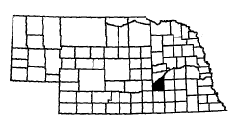
Communities Served:
Aurora Marquette
Giltner Phillips
Hampton Stockham
Hordville

Contact: Barbara Graham, Director
Hamilton County Senior Services
1205 11th St.

Aurora, NE 68818
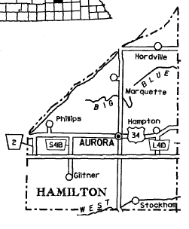

Telephone: (402) 694-2177
Fax: (402) 694-5120

Nebraska Association of Transportation Providers member

Description of System: Hamilton County Public Transportation provides service five days a week, Monday through Friday, for Hamilton County on a demand-response basis. Trips are made to towns in the county on a weekly basis. Reservations are required 24 hours in advance. Trips are made to Grand Island on the second and fourth Mondays.

Days and Hours of Operation:
Monday through Friday: 8:00 a.m. – 5:00 p.m.

Second and Fourth Monday: | Trips to Grand Island
Tuesday: | Marquette and Hordville area
Thursday: | Giltner and Phillips area
Friday: | Hampton and Stockham area
Any time the bus is not busy in other areas, it is available in Aurora and rural areas.

Rate Schedule:
$2.00 for round trip in Aurora, plus $0.50 per each additional stop
$5.00 per round trip from any outlying town in county
$7.00 per round trip to Grand Island

We also contract with HHS for block grant and waiver clients.

Number of Vehicles:
1 van, lift-equipped
1 backup van lift-equipped

Harlan County

Rural Public Transportation – Harlan County Transportation System
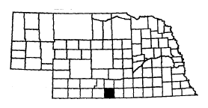
Communities Served:
Alma Ragan
Huntley Republican City
Orleans Stamford
Oxford

Contact: Marcia Roberts, Director
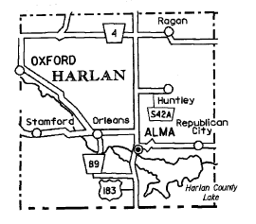
Harlan County Transportation System
Box 1023
Alma, NE 68920

Telephone: (308) 928-2149
Fax: (308) 928-2149

Nebraska Association of Transportation Providers member

Description of System: The primary geographical area of this system is all of Harlan County. The towns served on a need basis are Alma, Huntley, Orleans, Oxford, Republican City, Stamford and Ragan. Occasional trips out of county are made on a need basis.

Days and Hours of Operation:

Monday through Friday: 8:00 a.m. – 4:00 p.m.

 | These towns are served on an as-needed basis
Monday and Wednesday: | Alma
Tuesday: | Huntley and Republican City
Thursday: | Orleans
Friday: | Oxford and Ragan

Rate Schedule:
Public Transportation
$0.50 per one-way trip in county

Number of Vehicles:
2 vans, 1 lift-equipped

Hitchcock County

Rural Public Transportation – Hitch & Hay Public Transit
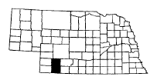
Communities Served:
Stratton Hamlet
Trenton Palisade
Culbertson Hayes Center

Contact: Gloria Gummere, Director
Hitchcock County Senior Center
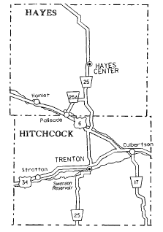
903 Bailey St., Box 81
Stratton, NE 69043

Telephone: (308) 276-2182

Description of System: Hitch & Hay Public Transit provides transportation service five days a week, Monday through Friday on a demand-response basis. Service from the six towns in Hitchcock and Hayes Counties to McCook, Benkelman and Imperial. The majority of the passengers are senior citizens and the disabled.

Days and Hours of Operation:
Monday through Friday: 8:00 a.m. – 5:00 p.m.
Office: Monday through Friday, 8:00 a.m. – 4:00 p.m.
Reservation requested 24 hours in advance

Monday: | Trip to Benkelman
Tuesday: | Trip to Wauneta and Imperial
Wednesday: | Trip to McCook
Thursday: | Trips within county towns
Friday: | Trip to McCook

Rate Schedule:
$3.00 one way out of county
$2.00 one way in county
$.25 per stop

Number of Vehicles:
1 van, lift-equipped
Holt County

Rural Public Transportation – Atkinson Senior Center

Community Served: Atkinson

Contact: Rossanne Schilz
Atkinson Senior Center
PO Box 58
Atkinson NE 68713

Telephone: (402) 925-5827
Fax: (402) 925-5827 (call first before faxing)

Nebraska Association of Transportation Providers member

Description of System: Atkinson Senior Center operates on a demand-responsive basis. Transportation is provided five days a week within Atkinson. Contact the Senior Center for hours of operation.

Days and Hours of Operation:
Monday through Friday:
8:00 a.m. – 4:30 p.m.

Rate Schedule:
Elderly – Disabled
Suggested donation $ .50 a round trip in Atkinson
Suggested donation $2.00 round trip outside city limits

General Public
Suggested donation $1.00 round trip in Atkinson
Suggested donation $4.00 round trip outside city limits

Number of Vehicles:
1 sedan
(Have contract with nursing home in Atkinson to provide ADA service when needed)

Holt County

Rural Public Transportation – Avera St. Anthony’s Hospital

Community Served: O’Neill

Contact: Brenda K. Halstead
Avera St. Anthony’s Hospital
300 N. 2nd Street
O’Neill, NE 68763

Telephone: (402) 336-5156
Fax: (402) 336-5139

Nebraska Association of Transportation Providers member

Description of System: Avera St. Anthony’s Hospital operates on a demand-responsive basis. Transportation is provided five days a week from 7:30 a.m. until 5:30 p.m. within the city limits of O’Neill and out of town on demand days a week with hours as needed to provide service.

Days and Hours of Operation:
Monday through Friday:
8:00 a.m. – 4:30 p.m.

Rate Schedule:
Elderly – Disabled
In town $1.00 per one-way trip
Out of town suggested $0.37/mile

General Public
In town $2.00 per one-way trip
Out of town $0.37/mile

Number of Vehicles:
1 lowered-floor mini-van, lift equipped with ramp for wheelchair accessibility
1 12-passenger Chevrolet small bus with lift and space for 2 wheelchairs

Hooker County

Rural Public Transportation – Hooker County Handi Bus
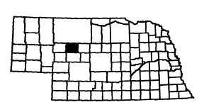
Community Served: Mullen

Contact: Dave Sullivan
Hooker County Clerk
Box 184
Mullen, NE 69152

Telephone: (308) 546-2244
Fax: (308) 546-2490
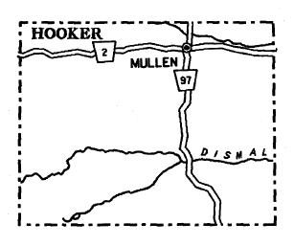
Driver: (308) 546-9300
Bus Cell: (308) 546-9347

Description of System: Demand-responsive service is provided throughout Hooker County. One day per week, based on need, the bus travels to North Platte and returns. It provides transportation to Hooker County riders in North Platte, while they are there.

Days and Hours of Operation:
Monday through Friday:
8:00 a.m. – noon and 1:00 p.m. – 5:00 p.m.

Rate Schedule:
Elderly – Disabled
Within Hooker County - Donations are accepted
Round trips to North Platte from Hooker County - $4.00 per one-way trip

General Public
Within Hooker County - Donations are accepted
Round trips to North Platte from Hooker County - $7.50 per one-way trip

Number of Vehicles:
1 van, lift-equipped

Howard County

Rural Public Transportation – Midland Area Agency on Aging
Howard County HandiBus

Communities Served:
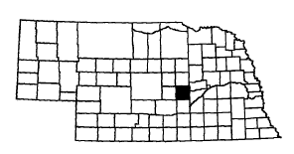
Boelus Elba
Cotesfield Farwell
Cushing St. Libory
Dannebrog St. Paul

Contact: Howard County HandiBus
Donetta Nye
St. Paul Community Center
808 Howard Street
St. Paul, NE 68873

Telephone: (308) 754-5452
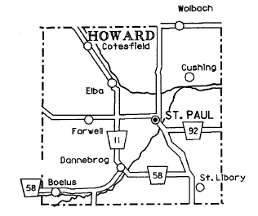
Fax: (308) 754-6227

Nebraska Association of Transportation Providers member

Description of System: The transit service is designed to serve the residents of Howard County, Nebraska. Vehicle and operations are based in St. Paul, at the St. Paul Community Senior Center. All outlying communities (Boelus, Cotesfield, Cushing, Dannebrog, Elba, Farwell, and St. Libory) are served. Transportation is available to the St. Paul residents five days a week. All rides are portal-to-portal with a 24-hour advance registration. One bus with wheelchair lift, can haul two wheelchairs and one mini van wheelchair equipped.

Days and Hours of Operation: Monday through Friday: 8:00 a.m. – 4:00 p.m.
Monday: Pickup in all towns in Howard County for trip to Grand Island
Wednesday: Pickup in Dannebrog, Boelus and St. Libory for delivery to St. Paul
Friday: Pickup in Farwell, Elba, Cotesfield and Cushing for delivery to St. Paul
Monday through Friday: Service in St. Paul

Rate Schedule: Elderly – Disabled – General Public
$0.50 per ride in St. Paul
$3.25 per ride rest of county to St. Paul
$5.25 per ride to Grand Island from St. Paul
$6.25 per ride to Grand Island from surrounding communities

Number of Vehicles:
1 bus, lift-equipped, 2 wheelchairs
1 mini-van, wheelchair equipped
Jefferson County

Rural Public Transportation – Blue Rivers Transportation System
Communities Served:

Alexandria | Fairbury | Jansen | Steele City
Daykin | Gladstone | Plymouth | Thompson
Diller | Harbine | Powell
Endicott | Hubbell | Reynolds

Contact: Larry Ossowski, Director

Blue Rivers Area Agency on Aging
Room 24, Courthouse

612 Grant St.
Beatrice, NE 68310
Local Contact: Nancy Schwisow in
Fairbury

Telephone: (402) 729-6475

Nebraska Association of Transportation Providers member

Description of System: The Blue Rivers Transportation System operates in Jefferson County of southeast Nebraska on a demand-response, portal-to-portal, 24-hour advance reservation basis. Vehicles are stationed in Fairbury. Surrounding community routes are scheduled on an as needed, once a week basis. Inter-City (West) provides transportation to Lincoln and Beatrice 3 days per week.

Days and Hours of Operation:
Monday through Friday: 8:00 a.m. – Noon and 1:00 p.m. – 5:00 p.m.
Route times: 8:00 a.m. – 10:00 a.m.; Return route 2:30 p.m. – 4:00 p.m., as requested
Monday: Fairbury to Daykin, Alexandria, Powell, Gladstone and return to Fairbury
Tuesday: Service from Fairbury to Hubbell, Reynolds, Thompson and return to Fairbury
Every Wednesday: Van in Fairbury
Thursday: Fairbury to Endicott, Steele City, Diller and return to Fairbury
Friday: Fairbury to Jansen, Harbine, Plymouth and return to Fairbury
Connects with intercity western route on Mondays, Wednesdays, and Thursdays for trips to Lincoln.

Rate Schedule:
$1.25 per one-way trip within a community
$2.50 per one-way trip between communities
$6.00 per one-way trip to Lincoln

Number of Vehicles:
Two 11-passenger vans with lifts
Johnson County

Rural Public Transportation – City of Tecumseh and Johnson County Public Transit

Communities Served:
Cook St. Mary
Crab Orchard Sterling
Elk Creek Tecumseh

Contact: Linda Schultz Steven G. Waring
City of Tecumseh City Clerk
122 South 4th Street 122 South 4th Street
P.O. Box 417 P.O. Box 417
Tecumseh, NE 68450 Tecumseh, NE 68450
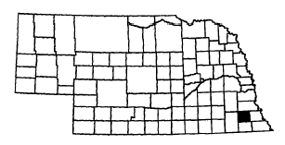
Telephone: (402) 335-2030
Fax: (402) 335-3185

Nebraska Association of Transportation Providers member

Description of System: The system serves all Johnson County. The bus is in Tecumseh and surrounding areas on Tuesday and Thursday all day, and on Wednesday and Friday afternoons. The Johnson County riders are on a scheduled route. The bus goes to Sterling every Wednesday morning and to Cook every Friday morning. The first Monday of the month, the bus goes from Tecumseh to Cook to Lincoln. The second Monday of the month, the bus goes from Tecumseh to Sterling to Beatrice. The third Monday of the month, the bus goes from Tecumseh to Sterling to Lincoln. The fourth Monday of the month, the bus remains in Tecumseh and surrounding areas all day.
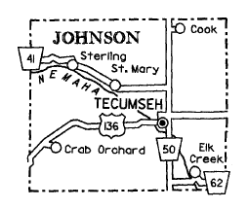

Days and Hours of Operation:
Monday through Friday:
8:00 a.m. – Noon and 1:00 p.m. – 4:30 p.m.

Rate Schedule:
Elderly – Disabled and General Public
$0.20 per ride for city
$0.40 per ride for county
$2.00 per ride for out of county

Number of Vehicles:
1 van, lift-equipped
Kearney County

Rural Public Transportation – Kearney County Public Transportation

Communities Served:
Axtell Minden
Hildreth Wilcox
Norman Newark
Heartwell

Contact: Rhonda Nokes
403 N. Colorado
Minden, NE 68959

Telephone: (308) 832-2139 Web: www.mnca.net
Fax: (308) 865-1358 E-mail: jrumery@mcna.net

Nebraska Association of Transportation Providers member
Heartland ITS
Community Transportation Association of America member
Governors Transportation Access Working Group

Description of System: Kearney County Public Transportation, operated by Community Action Partnership of Mid-Nebraska, serves Kearney County with demand responsive, portal to portal service, Monday through Friday in Minden and scheduled weekly service to towns in Kearney County. Service should be scheduled 24 hours in advance, rides scheduled less than 24 hours in advance are on an as available basis.

Days and Hours of Operation:
Monday: 8:30 a.m. to Noon Minden to Axtell and return
2:00 p.m. to 5:00 p.m. Minden service
Tuesday: 8:30 a.m. to Noon in Minden
1:00 p.m. to 5:00 p.m. Minden to Axtell
Every other week: from Axtell to Kearney
Wednesday: 8:00 a.m. to Noon in Minden
1:00 p.m. to 5:00 p.m. Wilcox to Minden and return or
Wilcox to Holdrege and return
(On alternate weeks)
Thursday: 8:00 a.m. to Noon in Minden
1:00 p.m. to 5:00 p.m. Minden to Kearney and return
Friday: Service in Minden all day
Note: Service provided to Norman, Heartwell, and Newark on request

Rate Schedule:
In town, one way: $1.00 Out of town, scheduled, one way: $1.50

Number of Vehicles:
One 9-passenger van, lift-equipped
Keith County

Rural Public Transportation – City of Ogallala Public Transit
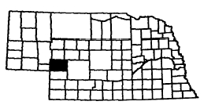
Contact: Steve Krajewski Carol Maxson
City Manager Transportation Director
411 East 2nd 411 East 2nd
Ogallala, NE 69153 Ogallala, NE 69153

Telephone: (308) 284-6400 (OPT office) or 284-6001 (City Manager)
Fax: (308) 284-6565

Nebraska Association of Transportation Providers member
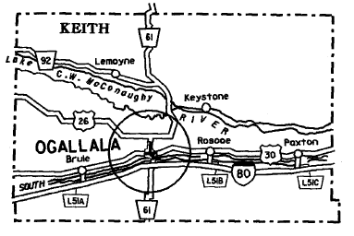
Description of System: The City of Ogallala covers up to a one mile radius outside the Ogallala city limits 7 days a week with a demand-responsive system. Service is provided to the general public with emphasis on the needs of the elderly and handicapped. Last minute calls are served whenever possible, but a 2-hour notice is requested for scheduling purposes.

Days and Hours of Operation:
Monday through Friday: 7:30 a.m. – 4:00 p.m.
Saturday: 8:00 a.m. – 4:00 p.m.
Sunday: 8:00 a.m. – 2:00 p.m.

Rate Schedule:
$1.00 per boarding
$2.00 outside city limits

Number of Vehicles:
Two 14-passenger small buses, lift-equipped
Kimball County

Rural Public Transportation – Kimball County Shuttle
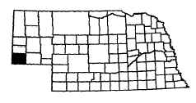
Communities Served:

Bushnell
Dix
Kimball

Contact: Elsie Vogel, Coordinator
Kelly Durbin, Driver
Kimball/Banner Extension Service
209 East 3rd Street
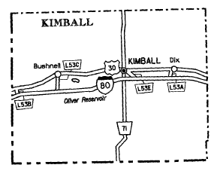
Kimball, NE 69145

Kimball County Web Page:
www.co.kimball.ne.us/content/shuttle

Telephone:
Coordinator (Annex Bldg): (308) 235-3122
Driver (cell phone): (308) 235-5333

Fax: (308) 235-3077

Nebraska Association of Transportation Providers member

Description of System: The Kimball County Shuttle serves the entire County from 9:00 a.m. to 4:00 p.m., Monday through Friday, except holidays, from its base of operation at the Annex Building in Kimball. The Kimball County Shuttle provides transportation for the elderly and public of Kimball County. The shuttle allows increased access for people to meals, health care, shopping, public services and recreation.

Days and Hours of Operation:
Monday through Friday: 9:00 a.m. – 4:00 p.m. (except holidays)

Rate Schedule:
Elderly (60 and older) – Disabled
$0.50 per round trip

General Public
$1.00 per round trip

Number of Vehicles:
1 van, lift-equipped
Knox County

Rural Public Transportation – Creighton Area Health Services
Van Service
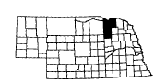
Communities Served:
Bloomfield Orchard
Brunswick Plainview
Center Verdigre
Creighton Wausa
Niobrara Winnetoon

Contact: Gladys Harder Paul Hurd, C.E.O.
Creighton Area Health Services Creighton Area Health Services
1503 Main, Box 186 1503 Main, Box 186
Creighton, NE 68729-0186 Creighton, NE 68729-0186

Telephone: (402) 358-5700
Fax: (402) 358-5769
E-mail: phurd@ne.org
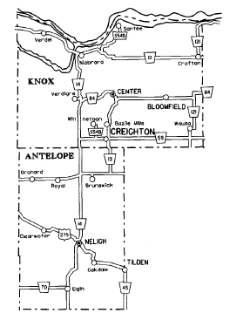

Description of System: The transit system provides demand-responsive service and wheelchair-accessible service for communities within the service area of Creighton Area Health Services. This may include transportation to doctor’s offices, shopping, and other appointments.

Days and Hours of Operation:
Monday through Friday: 8:00 a.m. – 4:30 p.m.
On-call service available on weekends

Rate Schedule:
In town - $1.00 per one-way trip
Out-of-town – 0-25 miles, $3.00 one-way/$6.00 round trip
26-40 miles, $6.00 one-way/$12.00 round trip
These prices apply within our service area.

Long distance trips available. Trips to Omaha, Lincoln, Norfolk and Yankton, S.D. Rates are negotiable. Please contact us. “Buy-A-Ride” coupons are available at $1.00 each at the CAHS Business Office.

Number of Vehicles:
1 van, lift-equipped
Lancaster County

Rural Public Transportation – Lancaster County Rural Transit

Communities Served:
Adams Firth Prairie Home
Agnew Greenwood Princeton
Bennet Hallam Raymond
Ceresco Hickman Roca
Cheney Holland Sprague
Cortland Kramer Walton
Davey Malcolm Waverly
Denton Martell
Emerald Panama
Contact: Wayne McClaran
Lancaster County Rural Transit
2202 South 11th
Lincoln, NE 68502

Telephone: (402) 441-8815
Fax: (402) 441-7869

Nebraska Association of Transportation Providers member

Description of System: The system provides modified demand-response service to residents of rural Lancaster County into Lincoln. The county is divided into two sections with each section being served two days per week. The service provides early morning pick-ups at riders’ homes and mid-afternoon returns. Reservations are requested 24 hours in advance. Call Monday through Friday from 9:00 a.m. to 12:00 noon and from 1:00 p.m. to 4:00 p.m. Exceptions: New Year’s Day, Martin Luther King Jr. Birthday, Presidents’ Day, Memorial Day, Independence Day, Labor Day, Veterans’ Day, Thanksgiving Day, Christmas Day, or days when these holidays are observed.

Days and Hours of Operation:
Monday through Thursday: Morning pick-ups between 8:00 a.m. and 9:30 a.m.
Mid-afternoon returns between 2:00 p.m. and 3:30 p.m.
Monday and Wednesday: Ceresco, Davey, Agnew, Raymond, Malcolm, Emerald and Denton, Greenwood, Waverly, Prairie Home and Walton
Tuesday and Thursday: Cortland, Hallam, Kramer, Princeton, Sprague and Martell, Adams, Firth, Holland, Hickman, Roca, Cheney, Bennet and Panama

Rate Schedule:
$1.50 per one-way trip

Number of Vehicles:
2 vans, both lift-equipped

Lincoln County

Rural Public Transportation – North Platte Public Transit System
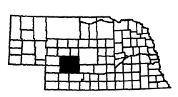
Contact: Marilee Hyde
1300 S. McDonald Rd.
North Platte, NE 69101

Telephone: (308) 535-6772
Fax: (308) 535-6776

Nebraska Association of Transportation Providers member
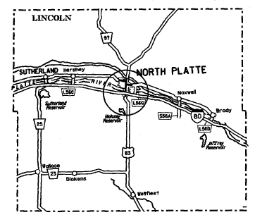
Description of System: The North Platte Public Transit System provides transportation five days a week, Monday through Saturday, on a demand-response basis and a scheduled bus route 5 days a week, Monday through Friday.

Demand-Response Bus
Days and Hours of Operation:
Monday through Friday 7:00 a.m. – 6:00 p.m. (except holidays)

Rate Schedule:
$1.00 per boarding

Road Runner Route Bus (Scheduled Route and Times)
Days and Hours of Operation:
Monday through Friday
9:30 a.m. – 3:30 p.m. (except holidays)

Rate Schedule:
$0.50 per ride

Number of Vehicles:
Five 12-passenger buses, lift-equipped
One 14-passenger bus, lift-equipped
One 7-passenger van, lift-equipped
Madison County

Rural Public Transportation – Norfolk Public Transportation
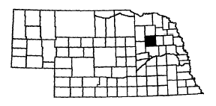
Contact: Vicki Goeken
Coordinator
Norfolk Public Transportation
307 Prospect
P.O. Box 302
Norfolk, NE 68702

Telephone: (402) 379-4595
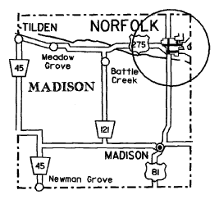
Fax: (402) 371-8626

Nebraska Association of Transportation Providers member

Description of System: Norfolk Public Transportation provides demand-responsive service within the city of Norfolk and immediate surrounding area. Additional service for the elderly and the disabled is contracted for with the local taxi cab company.

Days and Hours of Operation:
Monday through Friday:
7:00 a.m. – 5:30 p.m.

Rate Schedule:
Elderly – Disabled
$1.00 per trip handi bus
$3.25 per trip taxi

General Public
$2.00 per trip handi bus

Number of Vehicles:
2 vans, lift-equipped
1 minivan
Merrick County

Rural Public Transportation – Central City Mini Bus

Communities Served:
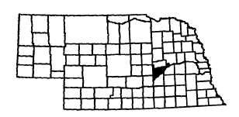
Central City
Clarks
Palmer

Contact: Alice Butt David Rish
Senior Center City Clerk
803 “C” Avenue Box 418
Central City, NE 68826 Central City, NE 68826

Telephone: (308) 946-3779
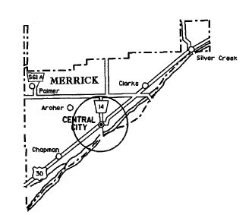
Fax: (308) 946-3334

Nebraska Association of Transportation Providers member

Description of System: The Central City Mini Bus provides five days a week transportation for senior citizens, disabled and the general public. Two trips per month are scheduled for Grand Island. A 24-hour advance reservation is requested.

Days and Hours of Operation:
Monday through Friday: 8:00 a.m. – 4:00 p.m.
First and third Monday to Grand Island, all day
Medical transportation throughout Merrick County on request using second bus.

Rate Schedule: 20 punch tickets are sold for $10.00
1 punch or $0.50 per one-way trip in city limits of Central City
$10.00 per round trip to Grand Island

Number of Vehicles:
2 vans, both lift-equipped

Morrill County

Rural Public Transportation – Morrill County Handi Bus

Communities Served:
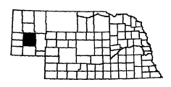
Bayard
Bridgeport
Broadwater

Contact:

Dale Frickey Nancy Eichthaler, Coordinator/Dispatcher
Morrill County Handi Bus Morrill County Handi Bus
Box 776 Box 776
Bridgeport, NE 69336 Bridgeport, NE 69336
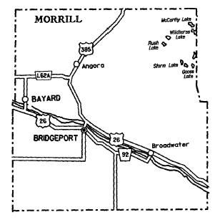

Telephone: (308) 262-1846
Fax: (308) 262-1846

Nebraska Association of Transportation Providers member

Description of System: The Morrill County Handi Bus is a demand-responsive county service. Service is provided one day a week in Bridgeport and one day a week in Bayard. Half-day service is provided to Broadwater. One day a week a trip from the three towns to Scottsbluff is scheduled. One day a month, Bayard to Bridgeport.

Days and Hours of Operation:

Monday through Thursday
Monday: | In Bridgeport | 11:00 a.m.– 4:00 p.m.
First, third and fifth Tuesday: | Broadwater to Bridgeport | 8:00 a.m. – 12:00 p.m.
Second and fourth Tuesday: | Bridgeport to Scottsbluff | 8:00 a.m. – 4:00 p.m.
First, third and fifth Wednesday: | Bridgeport to Scottsbluff | 8:00 a.m. – 4:00 p.m.
Second and fourth Wednesday: | Broadwater to Bridgeport | 8:00 a.m. – 12:00 p.m.
Thursday: | In Bayard | 8:30 a.m.– 4:00 p.m.
Second Friday: | Bayard to Bridgeport | 8:00 a.m. – 12:00 p.m.
Last Friday of month | Broadwater to Scottsbluff | 8:00 a.m. – 4:00 p.m.

Rate Schedule:

Elderly – Disabled  (round trip rate) |  | General Public  (round trip rate)
Bridgeport (in town) | $0.50 | Bridgeport (in town) | $1.00
Bayard (in town) | $0.50 | Bayard (in town) | $1.00
Broadwater to Bridgeport | $1.00 | Broadwater to Bridgeport | $2.00
Bridgeport to Scottsbluff | $2.00 | Bridgeport to Scottsbluff | $4.00
Broadwater to Scottsbluff | $2.00 | Broadwater to Scottsbluff | $4.00
Bayard to Scottsbluff | $2.00 | Bayard to Scottsbluff | $4.00
Bayard to Bridgeport | $1.00 | Bayard to Bridgeport | $2.00

Number of Vehicles:
1 van, lift-equipped
Nance County

Rural Public Transportation – Fullerton Van
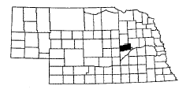
Communities Served:
Belgrade
Fullerton

Contact: Neva Umstead
Fullerton Area Senior Center
329 Broadway Street
Fullerton, NE 68368

Telephone: (308) 536-2123

Nebraska Association of Transportation Providers member
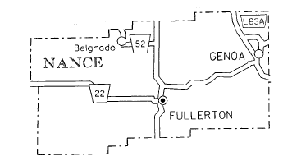
Description of System: The Fullerton Van provides a demand-response service. This service is open to all citizens of the Fullerton area, young and old alike. The fares are set as contribution suggestions. Reservations are appreciated.

Days and Hours of Operation:
Monday through Friday:
9:00 a.m. – 5:00 p.m.
Weekends are negotiable and worked out with the manager and driver.

Rate Schedule:
Suggested contribution:
Local in-town – $0.50 per stop
Out of town – $0.36 per mile
$1.00/hour waiting/sitting fee

Number of Vehicles:
1 van, lift-equipped
Nemaha County

Rural Public Transportation – Blue Rivers Transportation System
Communities Served:

Auburn | Brownville | Johnson | Nemaha
Brock | Howe | Julian

Contact: Larry Ossowski, Director
Blue Rivers Area Agency on Aging
Room 24, Courthouse
612 Grant St.
Beatrice, NE 68310
Local Contact: Kathy Oestmann or Stac Wheeler in Auburn

Telephone: (402) 274-5365

Nebraska Association of Transportation Providers member

Description of System: The Blue Rivers Transportation System operates in Nemaha County of southeast Nebraska on a demand-response, portal-to-portal, 24-hour advance reservation basis. Vehicle is stationed in Auburn. Surrounding community routes are scheduled on an as needed, once a week basis. Inter-City (East) route provides transportation to Lincoln, Nebraska City, Syracuse and Omaha.

Days and Hours of Operation:
Monday through Friday: 8:00 a.m. – Noon and 1:00 p.m. – 5:00 p.m.
Route times: 8:30 a.m. – 9:45 a.m.; Return route 3:00 p.m. – 4:30 p.m., if requested
Monday: Auburn to Peru, Brownville, Nemaha, Howe and return to Auburn
Tuesday, Wednesday, Friday: Van in Auburn 8:00 a.m. – 5:00 p.m.
Thursday: Auburn to Johnson, Brock, Julian and return
Connects with intercity eastern route on Tuesdays and Fridays for trips to Lincoln and with Omaha route on Wednesdays.

Rate Schedule:
$1.25 per one-way trip within a community
$2.50 per one-way trip between communities
$6.00 per one-way trip to Lincoln, Omaha, and Hastings

Number of Vehicles:
One 11-passenger van with lift
Nuckolls County

Rural Public Transportation – Midland Area Agency on Aging
Nuckolls County Senior Services
Public Transportation
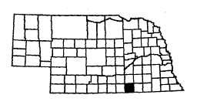
Communities Served:
Hardy Oak
Lawrence Ruskin
Nelson Superior
Nora

Contact: Nuckolls County Senior Services
Public Transportation
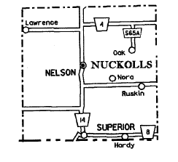
Kelly Siefried, Director
447 N. Central Avenue
Superior, NE 68978

Telephone: (402) 879-4679
Fax: (402) 879-4959

Nebraska Association of Transportation Providers member

Description of System: Public Transportation is available within Superior five days a week (9:00 a.m. – 5:00 p.m. Tuesday and Friday; 9:00 a.m. – 4:00 p.m. Monday, Wednesday, Thursday). A countywide service is available as needed from outlying towns to Superior. Countywide service is available as needed with one week’s notice and availability of a driver. The first Wednesday and second Friday of each month a scheduled trip is made to Hastings on a demand-responsive basis. Trips must be scheduled by noon on Tuesday and Thursday. Medical appointments are given priority.

Days and Hours of Operation:
Superior – Monday, Wednesday & Thursday 9:00 a.m. – 4:00 p.m.
Tuesday and Friday from 9:00 a.m. – 5:00 p.m.

Hastings – First Wednesday and second Friday of each month, 8:00 a.m. until return.

Rate Schedule:
All
$0.50 per stop in Superior
$5.00 round trip in county
$10.00 round trip to Hastings

Number of Vehicles:
1 van, lift-equipped
1 mini-van
Otoe County (Eastern)

Rural Public Transportation – Blue Rivers Transportation System
Communities Served:

Avoca | Lorton | Nehawka | Union
Dunbar | Nebraska City | Talmage

Contact: Larry Ossowski, Director

Blue Rivers Area Agency on Aging
Room 24, Courthouse
612 Grant St.
Beatrice, NE 68310
Local Contact: Catherine Balfour or Marsha Thompson in Nebraska City
Telephone: (402) 873-3005

Nebraska Association of Transportation Providers member

Description of System: The Blue Rivers Transportation System operates in eastern Otoe County of southeast Nebraska on a demand-response, portal-to-portal, 24-hour advance reservation basis. Vehicle is stationed in Nebraska City. Surrounding community routes are scheduled on an as needed, once a week basis. BRAAA contracts with a private cab company in Nebraska City for off-hour or peak-time transportation service. Inter-City (East) route provides transportation to Lincoln, Syracuse and Omaha.

Days and Hours of Operation:
Monday through Friday: 8:00 a.m. – Noon and 1:00 p.m. – 5:00 p.m.
Route times 8:30 a.m. – 10:00 a.m. and Return 3:00 p.m. – 4:30 p.m., if needed
Monday: Nebraska City to Talmage, Lorton, Dunbar and return to Nebraska City
Tuesday and Thursday: Van in Nebraska City all day
Wednesday: Van in Nebraska City
Friday: Nebraska City to Avoca, Union, Nehawka and return to Nebraska City
All routes on needed basis only. Connects with intercity eastern route on Tuesdays, Wednesdays and Fridays for trips to Lincoln and with Omaha route on Wednesdays.

Rate Schedule:
$1.25 per one-way trip within a community
$2.50 per one-way trip between communities
$6.00 per one-way trip to Lincoln, Omaha, and Hastings
$2.25 per one-way trip – taxi contract within city limits

Number of Vehicles:
One 5-passenger van – ADA accessible
Otoe County (Western)

Rural Public Transportation – Blue Rivers Transportation System
Communities Served:

Avoca | Douglas | Otoe | Syracuse
Burr | Lorton | Palmyra | Talmage
 |  |  | Unadilla

Contact: Larry Ossowski, Director
Blue Rivers Area Agency on Aging
Room 24, Courthouse
612 Grant St.
Beatrice, NE 68310

Local Contact: Carol Graham in Syracuse

Telephone: (402) 269-5129

Nebraska Association of Transportation Providers member

Description of System: The Blue Rivers Transportation System operates western Otoe County of southeast Nebraska on a demand-response, portal-to-portal, 24-hour advance reservation basis. Vehicle is stationed in Syracuse. Surrounding community routes are scheduled on an as needed, once a week basis. Inter-City (East) route provides transportation to Lincoln and Omaha.

Days and Hours of Operation:
Tuesday through Friday: 8:00 a.m. – Noon and 1:00 p.m. – 5:00 p.m.
Route times: 8:30 a.m. – 10:00 a.m. and return 3:00 p.m. – 4:30 p.m., if requested
Tuesday, Thursday and first, second and third Fridays: Syracuse to Unadilla, Palmyra, Otoe, Avoca, Douglas, Burr and return to Syracuse. Van available in Syracuse.
Wednesday: Van available in Syracuse. Connects with intercity eastern route on Tuesdays, Wednesdays and Fridays for trips to Lincoln and with Omaha route on Wednesdays.

Rate Schedule:
$1.25 per one-way trip within a community
$2.50 per one-way trip between communities
$6.00 per one-way trip to Lincoln, Omaha

Number of Vehicles:
One 11-passenger van with lift

Pawnee County

Rural Public Transportation – Pawnee County Handi Bus
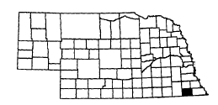
Communities Served:
Burchard | Lewiston | Steinauer
DuBois | Pawnee City | Table Rock

Contact: Ann Martinez, Transportation Coordinator
Southeast Nebraska Community Action
Box 646
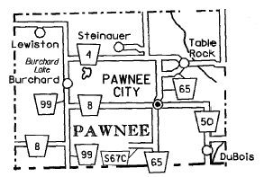
Humboldt, NE 68376-0646

Telephone: (402) 862-2411, Ext. 103
Fax: (402) 862-2428

Nebraska Association of Transportation Providers member

Description of System: The Pawnee County Handi Bus provides three-day per week, Tuesday through Thursday. Mondays as needed. The system operates on a demand-responsive basis. Out-of-town trips are on a monthly scheduled basis to Tecumseh, Beatrice, Humboldt, Lincoln, and Omaha.

Days and Hours of Operation:
Monday through Friday: 8:00 a.m. – 12:00 p.m., 12:30 p.m. – 2:30 p.m.
On days of scheduled trips to Lincoln and Beatrice, hours are as needed.

Weekly Schedule: |  | Pickup begins in Pawnee City at:
Mondays 1st | Beatrice | 8:00 a.m.
2nd | Lincoln | 8:00 a.m.
Tuesdays
Wednesdays 1st | Lincoln | 8:00 a.m.
2nd | Tecumseh | 8:00 a.m.
3rd | Local | 8:00 a.m.
4th | Local | 8:00 a.m.
5th | Local | 8:00 a.m.
Tuesdays | DuBois/Table Rock/Pawnee City | Pickup begins in DuBois at 9:00 a.m.  Table Rock at 9:30 a.m.
Thursdays | Steinauer/Lewiston/Burchard/Pawnee City | Pickup begins in Steinauer at 9:00 a.m.  Lewiston at 9:30 a.m.  Burchard at 9:45 a.m.

Rate Schedule:
$1.50 per one-way trip, 50 cents each additional stop
$4.50 between communities within county

Out-of-town/one-way:
$ 4.50 – Humboldt or Tecumseh
$ 5.50 – Beatrice or Falls City
$15.00 – Lincoln – with same day return
$20.00 – Lincoln – no return
$17.00 – Omaha – with same day return
$22.00 – Omaha – no return

Number of Vehicles:
1 van, lift-equipped
Perkins County

Rural Public Transportation – Perkins County Mini Bus
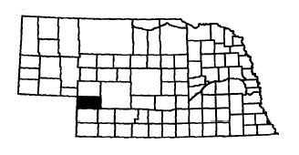
Communities Served:
Brandon | Grant
Elsie | Madrid
Grainton | Venango

Contact: Karen Glunz
Perkins County Senior Services
P.O. Box 314
Grant, NE 69140
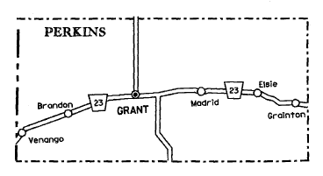

Telephone: (308) 352-4597

Nebraska Association of Transportation Providers member

Description of System: The Perkins County Mini Bus is a demand-responsive service. The bus runs west of Grant on Mondays and Thursdays, east on Tuesdays and Fridays, and is in Grant all day Wednesdays.

Days and Hours of Operation:
Monday through Friday: 9:00 a.m. – 4:00 p.m.

Rate Schedule:
Elderly – Disabled:
$1.00 per trip City of Grant
$2.00 per trip County
$7.00 per trip out of County

General Public:
$1.50 per trip City of Grant
$2.50 per trip County
$7.00 per trip out of County

Number of Vehicles:
1 small bus, lift-equipped
Phelps County

Rural Public Transportation – Phelps County Handi Bus

Communities Served:
Atlanta | Holdrege
Bertand | Loomis
Funk

Contact: Denise Smith
Phelps County Senior Citizens Service Centers, Inc.
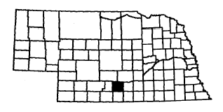
P.O. Box 587
Holdrege, NE 68949

Telephone: (308) 995-6788
Fax: (308) 995-8809

Nebraska Association of Transportation Providers member

Description of System: The Phelps County Handi Bus covers all of Phelps County on a demand-responsive basis. Service to Kearney is available every third Wednesday. Non-emergency medical transportation up to 250 miles, unit cost 50 cents per mile one-way. This service is available to all county residents. It is requested that reservations be made 24 hours in advance.
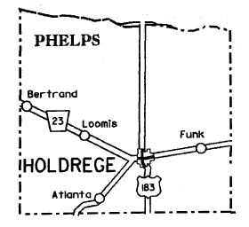

Days and Hours of Operation:
Monday through Friday: 8:00 a.m. – 5:00 p.m.

Rate Schedule:
Elderly – Disabled:
50 cents per boarding
$10.00 coupon book/20 rides @ 50 cents

General Public:
$1.00 per boarding

Number of Vehicles:
2 buses, lift-equipped
1 van
1 sedan
Platte County

Rural Public Transportation – Columbus Area Transit System

Contact: Pam Stephens Mike Oglevie
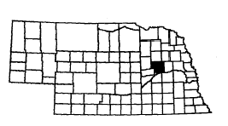
Senior Center Director Personnel Officer
2518 14th Street P.O. Box 1677
Columbus, NE 68601 Columbus, NE 68602-1677

Telephone: (402) 564-9293 (402) 564-4243
Fax: (402) 563-1380

Nebraska Association of Transportation Providers member
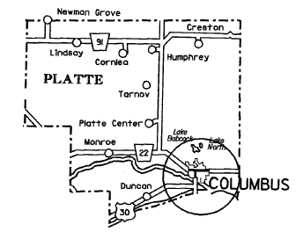
Description of System: Transportation service is provided on a demand-responsive basis within the city limits of Columbus. A minimal (set) fee is charged per boarding with transportation anywhere within city limits. Advance registrations are encouraged.

Days and Hours of Operation:
Monday through Friday: 8:00 a.m. – 5:00 p.m.

Rate Schedule:
Elderly – Disabled:
75 cents per boarding

General Public:
$4.00 per boarding

Number of Vehicles:
2 vans, lift-equipped
Red Willow County

Rural Public Transportation – City of McCook Handi Bus
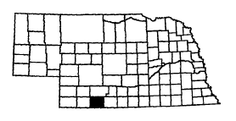
Contact: Sue Chipman
McCook Public Transit Coordinator
P.O. Box 1059
1312 West 5th Street
McCook, NE 69001

Telephone: (308) 345-6098
Fax: (308) 345-1461

Nebraska Association of Transportation Providers member
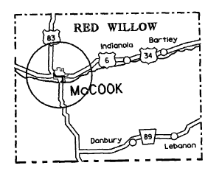
Description of System: The City of McCook Public Transit operates within the city limits five days a week. It is a dial-a-ride system and the dispatcher communicates with the driver by two-way radio.

Days and Hours of Operation:
Monday through Friday:
8:30 a.m. – 12:30 p.m. and
1:00 p.m. – 4:30 p.m.

Rate Schedule:
All individuals $1.00 per one-way trip.

Number of Vehicles:
1 bus, lift-equipped

Richardson County

Rural Public Transportation – Richardson County Transit System
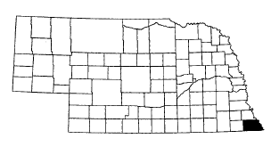
Communities Served:
Barada | Humboldt | Salem | Verdon
Dawson | Preston | Shubert
Falls City | Rulo | Stella

Contact: Ann Martinez, Transportation Coordinator
Southeast Nebraska Community Action
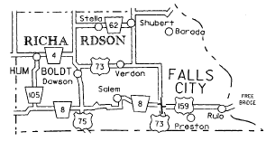
Box 646
Humboldt, NE 68376-0646

Telephone: (402) 862-2411, Ext. 103
Fax: (402) 862-2428

Nebraska Association of Transportation Providers member

Description of System: The Richardson County Transit System provides five-day per week, Monday through Friday, service. The system operates on a demand-responsive basis. Out-of-town trips are on a monthly scheduled basis to Lincoln and Omaha.

Days and Hours of Operation:
Monday through Friday: 8:30 a.m. – 11:30, 12:00 – 3:00 p.m.
Weekly Schedule: |  | Pickup begins at:
Tuesdays 1st & 3rd | Lincoln with 4 or more riders & 1 medical | 8:30 a.m.
2nd & 4th | Omaha with 4 or more riders & 1 medical | 8:30 a.m.
Wednesdays | Provide service to and from: Barada/Shubert/Stella/Verdon | 8:45 a.m.
 | Rulo/Preston | 10:30 a.m.
 | Barada/Shubert/Stella/Verdon | 1:00 p.m.
 | Rulo/Preston | 12:30 p.m.
Thursdays | Provide service to and from:  Verdon/Dawson/Humboldt/Salem | 8:45 a.m.
 | Verdon/Dawson/Humboldt/Salem | 1:00 p.m.

Rate Schedule:
$1.50 per one-way trip within the community, 50 cents additional stops
$3.50 one-way trips between Falls City and Barada/Preston/Rulo/Salem/Verdon
$4.50 one-way trips between Falls City and Dawson/Shubert/Stella
$5.50 one-way trips between Falls City and Humboldt
$17.00 one way to Lincoln or Omaha with same day return
$22.00 one-way trip to Lincoln or Omaha if not returning same day
Children 5 and under ½ fare with paying fare.

Fares are double on non-scheduled days.

Number of Vehicles:
1 van, lift-equipped
1 station wagon
Rock County

Rural Public Transportation – Rock County Handi Bus
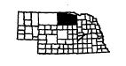
Communities Served:
Bassett | Springview
Long Pine | Stuart
Newport

Contact: Malissa Stec
Rock County Senior Center, Inc.
Box 59
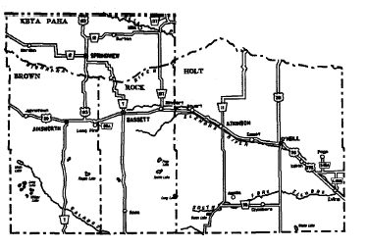
Bassett, NE 68714

Telephone: (402) 684-2295

Nebraska Association of Transportation Providers member

Description of System: The transit service provides demand-responsive service and the communities of Springview, Long Pine, and Stuart outside of the county boundaries. Vehicle and operations are based in Bassett, at the Rock County Senior Center. Transportation is available to residents of Bassett five days a week when the vehicle is not scheduled out of town.

Days and Hours of Operation:
Monday through Friday:
8:00 a.m. – 3:00 p.m.
Monday through Friday: as requested
Thursday: Service in Bassett every first and third Thursday of the month.
Hours of operation are from 1:00 p.m. to 10:00 p.m.

Rate Schedule:
Elderly – Disabled:
25 cents per boarding in Bassett
50 cents per boarding for out-of-town trips
$1.00 – outside geographical boundaries

General Public:
50 cents per boarding in Bassett
$1.00 per boarding for out-of-town trips
$2.00 – outside geographical boundaries

Number of Vehicles:
1 van, lift-equipped

Saline County

Rural Public Transportation – Saline County Area Transit
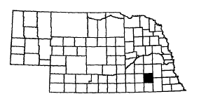
Communities Served:
Crete | Swanton
DeWitt | Tobias
Dorchester | Western
Friend | Wilber

Contact: Scott Bartels, Administrator
Saline County Area Transit
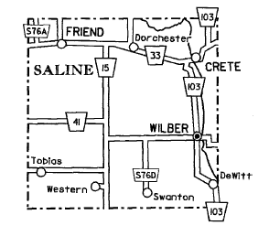
Box 412
Western, NE 68464

Telephone: (402) 433-4511
Fax: (402) 433-4511

Nebraska Association of Transportation Providers member
Description of System: Saline County Area Transit provides demand-responsive service from the eight towns in Saline County to Lincoln, Crete, Beatrice and Fairbury. Although the majority of the passengers are senior citizens and the disabled, service is also available to the general public.
Days and Hours of Operation:
Monday through Friday: 8:00 a.m. – 5:30 p.m.
Office – Monday through Thursday: 7:45 a.m. – 3:00 p.m.
Friday: 7:45 a.m. – Noon
Reservations requested 24 hours in advance
Monday through Friday: Route to Lincoln
Mondays: 1st & 3rd – Route to Crete
Tuesdays: All routes are now countywide
2nd – Route to Fairbury
3rd – Route to Crete
Thursdays: 1st, 3rd, & 5th – Countywide route to Beatrice
2nd – Route to Crete
4th – Route to Fairbury

Rate Schedule:
General Public:
In Saline County $3.00 one-way
Fairbury $4.00 one-way
Beatrice $4.00 one-way
Lincoln $5.00 one-way
To Lincoln Airport $6.00 one-way
Children: 6-10 years half fare; 5 years and under - free

Number of Vehicles:
2 buses, lift-equipped
One 15-passenger van
2 mini-vans
Saunders County

Rural Public Transportation – Saunders County Public Transportation

Communities Served:
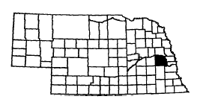
Ashland | Ithaca | Morse Bluff | Valparaiso
Cedar | Leshara | Plasi | Wahoo
Bluffs | Malmo | Prague | Wann
Ceresco | Mead | Swedeburg | Weston
Colon | Memphis | Touhy | Yutan

Contact: Laura Lindgren, Manager
Saunders County Public Transportation
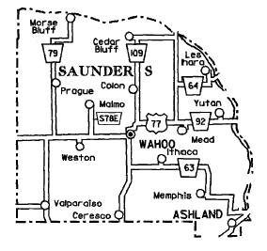
426 N. Broadway
Wahoo, NE 68066

Telephone: (402) 443-8168 or 1-800-331-7496
Fax: (402) 443-1091

Nebraska Association of Transportation Providers member

Description of System: The Saunders County Handi Van is a specialized portal-to-portal reservation scheduled system service residents of Saunders County. Trips are made to Fremont, Lincoln, and Omaha on a rotating basis on Tuesday and Thursdays. All of the 19 communities in the county are served at least one day every other week.

Days and Hours of Operation:
Monday through Friday, 8:00 a.m. – 5:00 p.m.
(Does not operate on county recognized holidays)
Handi Van Office: 8:00 a.m. – 12:00 noon
Reservations requested 24 hours in advance
Monday:
Service alternates
One Monday – Ashland, Ithaca, Wann, Memphis, and Ceresco
The other – Mead, Yutan, and Leshara
Tuesday:
Trips to Fremont, Lincoln and Omaha, rotating equally between the three cities
Wednesday:
Services alternates
One Wednesday – Prague, Weston, Valparaiso, Malmo, and Touhy
The other – Cedar Bluffs, Colon, and Morse Bluff
Thursday:
Trips to Fremont, Lincoln and Omaha, rotating equally between the three cities
Friday:
Wahoo

Rate Schedule:
$1.00 per boarding or
$2.00 per round trip traveling from town-to-town within county
$2.00 per boarding or $4.00 per round trip for out-of-county trips

Number of Vehicles:
1 van, lift-equipped
Scotts Bluff County

Rural Public Transportation – Scotts Bluff County Handy Bus
Public Transportation System

Communities Served:
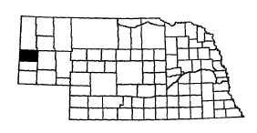
Gering | McGrew | Mitchell
Henry | Melbeta | Morrill
Lyman | Minatare | Scottsbluff

Contact: Scotts Bluff County Handy Bus Public Transportation System
Carol Prince
Administration Building
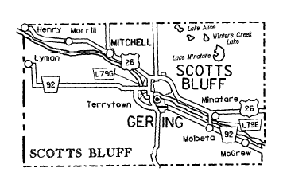
1825 10th Street
Gering, NE 69341

Telephone: (308) 436-6687
Fax: (308) 436-3154

Nebraska Association of Transportation Providers member

Description of System: The Scotts Bluff County system provides demand-response transportation to the entire county. The handy bus provides service to 3 congregate meal sites within the area of Scottsbluff, Gering and Mitchell, Monday through Friday. Outlying areas are served Monday through Friday on an as-needed basis. It is requested that reservations be made 24 hours in advance.

Days and Hours of Operation:
Monday through Friday:
8:00 a.m. – 4:30 p.m.

Rate Schedule:
75 cents per one-way ride

Number of Vehicles:
4 vans, lift-equipped
5 station wagons
Seward County

Rural Public Transportation – Seward County Handi Bus

Communities Served:
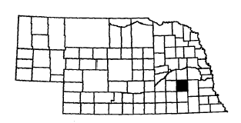
Beaver Crossing | Goehner | Staplehurst
Bee | Milford | Tamora
Cordova | Pleasant Dale | Utica
Garland | Seward

Contact: Russ Daehling
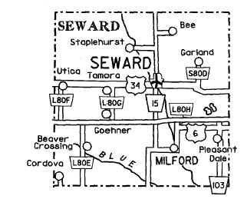
P.O. Box 190
Seward, NE 68434

Telephone: (402) 643-4067
Fax: (402) 643-3174

Nebraska Association of Transportation Providers member

Description of System: The Seward County Handi Bus serves the entire county. Service is portal-to-portal for all persons by reservation according to route schedule. Collect calls are accepted.

Days and Hours of Operation:
Monday through Friday:
8:00 a.m. – 5:00 p.m.

Monday (a.m.) | Residents of Tamora, Goehner, Beaver Crossing, Cordova, and Utica can have transportation to Seward
Monday (p.m.) | Seward residents can ride to Utica
Tuesday (a.m.) | Residents of Bee, Garland, and Staplehurst can ride to Seward
Tuesday (p.m.) | Seward residents are provided transportation to downtown Seward
Wednesday | 1st Wednesday, anyone in Seward County can ride to the City of York. Remaining Wednesdays, trips to Lincoln alternate between the northern and southern halves of the county
Thursday (a.m.) | Milford and Pleasant Dale residents can ride to Seward
Thursday (p.m.) | Seward residents can ride to downtown Seward
Friday | Trips to Lincoln alternate between the northern and southern halves of the county

Rate Schedule:
$1.00 per trip anywhere in county to Seward
$3.00 per trip anywhere in county to Lincoln
Service is not denied to elderly – disabled due to inability to pay

Number of Vehicles:
1 van, lift-equipped
Sheridan County

Rural Public Transportation – Sheridan County Public Transportation
System (S.C.P.T.S.)
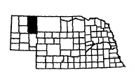
Communities Served:
Clinton | Hay Springs | Whiteclay
Gordon | Rushville

Contact: Kerry Carle
Northwest Community Action
270 Pine
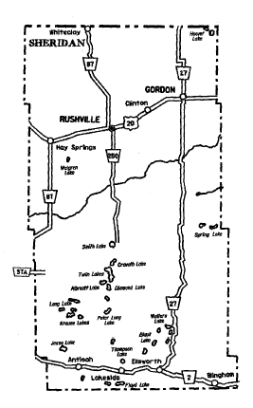
Chadron, NE 69337

Telephone: (308) 432-3393 or (308) 327-2877
Fax: (308) 432-5799

Nebraska Association of Transportation Providers member

Description of System: The Sheridan County Public Transportation System provides demand-response service in and between the communities in northern Sheridan County. Transportation is available five days a week, Monday through Friday.

Days and Hours of Operation:
Monday through Friday: by appointment

Rate Schedule:
Elderly – Disabled, General Public
30 cents per one-trip (suggested donation)
$2.50 per one-way trip between towns (suggested donation)

Number of Vehicles:
1 van, lowered-floor

Sherman County

Rural Public Transportation – Loup City Handi Bus
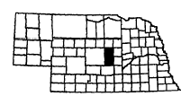
Communities Served:
Ashton | Loup City
Litchfield | Ord

Contact: Annette M. Gallaway
City Clerk
P.O. Box 250
Loup City, NE 68853
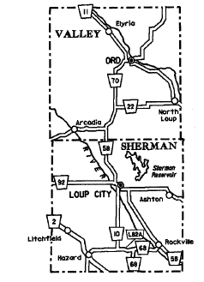

Telephone: (308) 745-0879 – Handi Bus
(308) 745-0222 – City Office
Fax: (308) 745-0734

Nebraska Association of Transportation Providers member

Description of System: The Loup City Handi Bus serves residents of Loup City, Ord, Ashton, and Litchfield, which are located in Sherman and Valley Counties. Out-of-town trips are made by reservation on a call-in basis until bus capacity is filled. Within city service is on a demand-responsive basis. The monthly schedule is posted at the Senior Citizen Center. Westside Park, low-income housing for elderly, and at both grocery stores in Loup City.

Days and Hours of Operation:
Mondays, Tuesdays, Wednesdays & Fridays:
8:30 a.m. – Noon and 1:00 p.m. – 4:30 p.m.
Within the City of Loup City

Thursdays 1st Loup City to Kearney 8:00 a.m. – 5:00 p.m.
2nd Litchfield to Kearney 8:00 a.m. – 5:00 p.m.
3rd Ashton to Grand Island 8:00 a.m. – 5:00 p.m.
4th Loup City to Grand Island 8:00 a.m. – 5:00 p.m.

Rate Schedule:
Free-will donations

Number of Vehicles:
1 van, lift-equipped
Thayer County

Rural Public Transportation – Blue Rivers Transportation System
Communities Served:

Alexandria | Carlton | Gilead
Belvidere | Chester | Hebron
Bruning | Davenport | Hubbell
Byron | Deshler

Contact: Larry Ossowski, Director
Blue Rivers Area Agency on Aging
Room 24, Courthouse

612 Grant St.
Beatrice, NE 68310
Local Contact: Janet Gergen in Hebron

Telephone: (402) 768-6052

Nebraska Association of Transportation Providers member

Description of System: The Blue Rivers Transportation System operates in Thayer County of southeast Nebraska on a demand-response, portal-to-portal, 24-hour advance reservation basis. Vehicle is stationed in Hebron. Surrounding community routes are scheduled on an as needed, once a week basis. Inter-City (West) provides transportation to Lincoln, Fairbury and Beatrice.

Days and Hours of Operation:
Monday through Friday: 8:30 a.m. – Noon and 1:00 p.m. – 4:30 p.m.
Route times 8:30 a.m. to 10:00 a.m.; Return route 3:00 p.m. – 4:00 p.m., as requested
Monday: Hebron to Hubbell, Chester, Byron, Deshler and return to Hebron
Tuesday: Hebron to Bruning, Carleton, Davenport and return to Hebron
First and third Wednesday: Hebron to Hastings and return to Hebron
Second and fourth Wednesday: Van in Hebron
Thursday: Hebron to Hubbell, Chester, Byron, Deshler and return to Hebron
Friday: Hebron to Gilead, Alexandria, Belvidere and return to Hebron
Connects with intercity western route on Mondays, Wednesdays, and Thursdays for trips to Lincoln, Beatrice and Fairbury.

Rate Schedule:
$1.25 per one-way trip within a community
$2.50 per one-way trip between communities
$6.00 per one-way trip to Lincoln, Omaha, and Hastings

Number of Vehicles:
One 11-passenger van with lift
Valley County

Rural Public Transportation – Valley County Transit System

Communities Served:
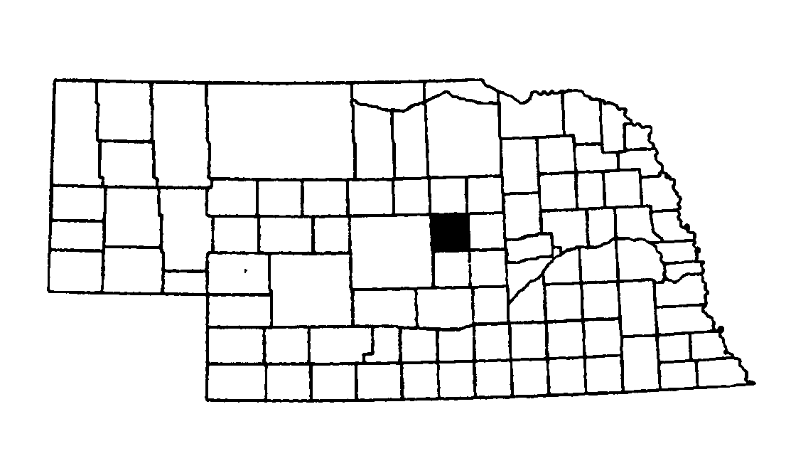
Arcadia | North Loup
Burwell | Ord
Comstock | Scotia
Ericson | Taylor
Loup City

Contact: Connie Fread
Valley County Hospital
217 Westridge Drive
Ord, NE 68862

Telephone: (308) 728-3211 or (308) 728-5581
Fax: (308) 728-3228
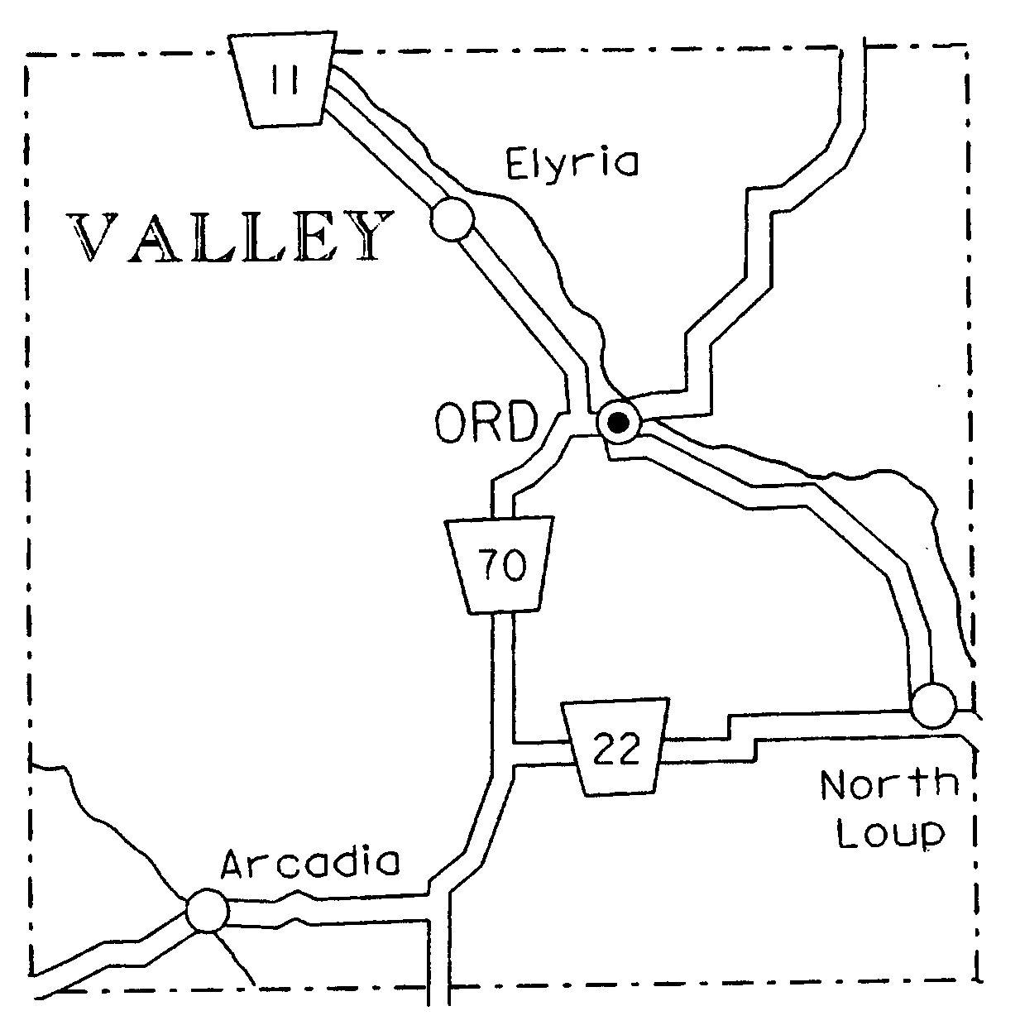

Description of System: The Valley County Hospital provides service five days a week, Monday through Friday, to Senior Classics of Ord, Inc., for rides to the Senior Center for noon lunches and to deliver meals to seniors who are unable to come to the Center. In addition, service is provided on a demand-responsive basis to all of Valley County and the surrounding counties of Greeley, Sherman, Loup, Garfield, Custer, Wheeler (or part of). Occasional service is provided on Saturday and Sunday.

Days and Hours of Operation:
Monday through Friday:
9:00 a.m. – 5:00 p.m.

Rate Schedule:
Contributions locally. Fee schedule outside of city limits.

Number of Vehicles:
2 vans, lift-equipped
Wayne County

Rural Public Transportation –Wayne Public Transit
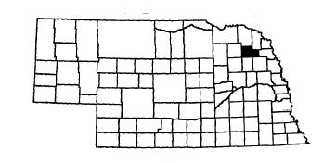
Communities Served:
Bladen | Cowles | Red Cloud
Blue Hill | Inavale | Rosemont  Wayne

Contact: Tracy Keating
Senior Center Coordinator
410 Pearl
Wayne, NE 68787

Telephone: (402) 375-1460
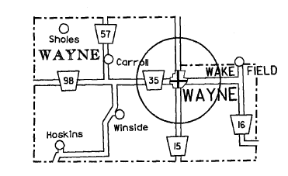
Fax: (402) 375-1460 (Call first)

Nebraska Association of Transportation Providers member

Description of System: The Wayne Public Transit service is a demand-responsive service. The system operates within the city limits of Wayne.

Days and Hours of Operation:
Monday through Friday:
9:00 a.m. – 5:00 p.m.

Rate Schedule:
$1.00 suggested donation per ride

Number of Vehicles:
1 van, lift-equipped
1 station wagon
1 bus, lift-equipped

Webster County

Rural Public Transportation – Village of Guide Rock Public Transit
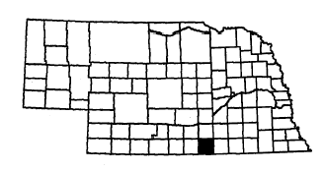
Contact: Cindy Sanders
Village Clerk
Box 41
Guide Rock, NE 68942

Telephone: (402) 257-3945
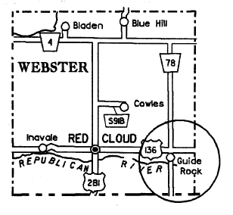
Nebraska Association of Transportation Providers member

Description of System: This is a demand-responsive system serving the residents of Guide Rock. One day a week or as demand requires, trips are made to Red Cloud, Blue Hill, Superior, Hastings and Mankato, Kansas.

Days and Hours of Operation:
Monday through Friday:
9:00 a.m. – 5:00 p.m.

Rate Schedule:

Round Trip
General Public
Guide Rock | $ .25
Blue Hill | 2.50
Hastings | 4.00
Red Cloud | 2.00
Superior | 2.50
Mankato, KS | 2.50

Number of Vehicles:
1 van, lift-equipped

Webster County

Rural Public Transportation – Webster County Transportation
Services
Communities Served:
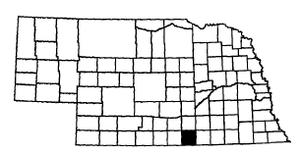
Bladen | Inavale
Blue Hill | Red Cloud
Cowles | Rosemont
Contact: Yvonne Stephens
432 North Elm
Red Cloud, NE 68970
Telephone: (402) 746-3251
Fax: (402) 746-3708
E-mail: ystephen@gpcom.net
Nebraska Association of Transportation Providers member

Description of System: The Webster County Transportation Services provides services to the communities and rural areas of Webster County. It is a demand-responsive service. Off schedule available (contact office for more details).
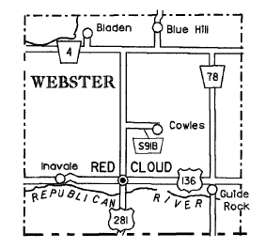

Days and Hours of Operation:
Monday through Friday, 8:00 a.m. – 4:00 p.m.
Blue Hill Daily M-F
Red Cloud – Blue Hill Daily (in-town service) M-F
Inavale Daily M-F
Cowles – Demand Responsive
Monday: (p.m.)
1st & 3rd – Countywide to Franklin
Tuesday: (p.m.)
1st & 3rd – Countywide to Superior M-F Daily
2nd & 4th – Countywide to Red Cloud – Inavale M-F Daily
Wednesday:
1st – Inavale
3rd – Kearney
4th – Grand Island
Tuesday & Thursday: (weekly)
Red Cloud – Bladen
Friday:
Countywide to Hastings

Rate Schedule:
In town – 40 cents per boarding
In county - $1.25 per boarding
Out of county $2.50 per boarding to Superior, Franklin, and Hastings
Non-scheduled trips – 50 cents per mile, 1 ½ hour wait time $9.50 thereafter (both ways)
Wheelchair - $6.25/trip in town (escort)

Number of Vehicles:
2 station wagons
1 bus, lift equipped
1 mini van
York County

Rural Public Transportation – York County Transportation System
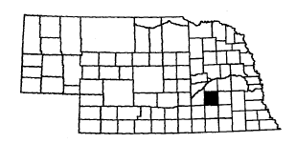
Communities Served:
Benedict | Henderson | Thayer
Bradshaw | Lushton | Waco
Gresham | McCool Junction | York

Contact: Carol Barr, Program Manager
Senior Information Center
Room 108, Courthouse
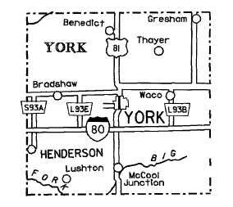
York, NE 68467

Telephone: (402) 362-7626
Fax: (402) 362-4735

Nebraska Association of Transportation Providers member

Description of System: The system consists of two vehicles, the county bus and the Busy Wheels. It is a demand-response service. The county bus provides service in the county to bring riders to York. The Busy Wheels provides rides in and around the City of York. County bus riders must make reservations 24 hours in advance. Busy Wheels accepts advance reservations, but provides same day service on a first-come, first-served basis. All citizens are eligible for service.

Days and Hours of Operation:
Monday through Friday: 8:00 a.m. – 5:00 p.m.
York County Bus:
Monday York and surrounding area
Tuesday Benedict, Gresham, McCool Junction and Waco riders to York
Wednesday Henderson and Bradshaw riders to York
Thursday Service to Grand Island and Lincoln
Friday Service within the City of York

Rate Schedule:
$1.00 per boarding in county
Day Pass – $3.00
$3.00 one-way for out-of-county
Destinations plus 50 cents for each additional stop within the destination city

Number of Vehicles:
1 van, lift-equipped
1 station wagon

